Safeguarding Adults at Risk Policy

Contents Page

AIMS, OBJECTIVES AND CONTECT 4-5

LEGAL FRAMEWORK 5-6

ROLE OF STAFF, VOLUNTEERS AND TRUSTEES 6-7

TYPES OF ABUSE 7-10

PROCEDURE IN THE EVENT OF DISCLOSURE 10-11

NON-RECENT ABUSE 11-12

CONFIDENTIALITY 13

ROLE OF KEY AGENCIES 13-15

KEY PERSONNEL 15-18

COMPLAINTS 18

RECRUITMENT PROCEDURE AND DBS CHECKS 18-19
References, internet links and further sources of information 19-22

Community Trust Commitment to Safeguarding
Statement from Director of Community and Education:
Fleetwood Town FC Community Trust is committed to safeguarding, as far as is reasonably practicable, children, young people and vulnerable groups. The Trust aims to create an atmosphere where everyone feels valued, safe and have their voices heard.
The Trust expects all staff, players, volunteers, contractors, partners and guests to share this commitment and understand that everyone has a responsibility for safeguarding, to be alert and to report any concerns about the welfare of any child, young person or adult at risk to the Trust.
The Trust is committed to ensuring that:
· 'Every vulnerable group and adult at risk has the right to protection. The safety and welfare of children, young people and adults at risk whilst under the care of the Trust is paramount;
· All children, young people and adults at risk that engage with the Trust, regardless of age, culture, social background, disability, gender, language, racial origin, religious belief and/or sexual identity have the right to safety and protection from abuse or harm;
· Listen to ALL adults at risk and take account of their wishes and feelings, both in individual decisions and in the development of services;
· All suspicions, reports and/or allegations of abuse will be taken seriously and investigated thoroughly and may involve appropriate local authority teams where necessary;
· Appropriate action is taken if/when necessary following any investigation of reported poor practice.
· Recognises and accepts its responsibility for the safety and well-being of those vulnerable adults who come within the care of the organisation and its staff, volunteers, board member and trustees of FT community Trust.
· Accepts its responsibility in the belief that the welfare and protection of vulnerable adults is paramount, and everyone responsibility. The Trusts policy is endorsed by the board of trustees at Fleetwood Town Community Trust.
· Systems are in place that will prevent or minimise the risk of abuse occurring within the organisation. As an integral part of this process, The Trust will ensure that all children and young people who train with The Trust will have access to Designated Persons and a complaints procedure. In all Safeguarding issues, the Trust will work under the guidance of the Local Safeguarding Children Board, Football Association (FA) the English football League/Trust. The safeguarding DSO and the SSM hold meeting the minutes in form the board/trustees of any concerns. The board/ trustees have endorsed this policy. The policy will be reviewed annually or within 4 weeks of any safeguarding incident or legislative change, the Trust will have in place
arrangements that reflect the importance of safeguarding and promoting the welfare of children, including a clear line of accountability for the commissioning and/or provision of service designed to safeguard and promote the welfare of children. A senior member at board level will take leadership responsibility for the Club’s safeguarding arrangements, Steve Curwood, SSM and Club CEO.
As a measure of the Trust’s commitment to safeguarding, a dedicated and trained Safeguarding team will implement, maintain, and embed best practice across all areas of operation.
The Safeguarding policy will also be continually monitored and subject to review annually, or following any incident or near miss of a safeguarding nature.
Signed on behalf of Fleetwood Town FC Community Trust
Jeremy Quartermain - Trustee Safeguarding lead:
Signature:
10.03.2022

1 Aim
1.1 The purpose of this policy is to outline the duty and responsibility of staff, volunteers and trustees working on behalf of the organisation in relation to Safeguarding Adults at Risk.
1.2 All adults have the right to be safe from harm and must be able to live free from fear of abuse, neglect and exploitation.
“Abuse is a violation of an individual’s human and civil rights by any other person or persons”
2 Objectives
2.1 To explain the responsibilities the organisation and its staff, volunteers and trustees have in respect of vulnerable adult protection.
2.2 To provide staff with an overview of adult at risk protection
2.3 To provide a clear procedure that will be implemented where adult at risk protection issues arise.
3 Context
3.1 For the purpose of this policy ‘adult’ means a person aged 18 years or over.
3.2 As part of this, the Safeguarding Policy will be reviewed annually or whenever there is an organisational change, the Trust implements a new activity or service which involves contact with children and/or adults at risk; change in legislation or following any learning outcomes from safeguarding incidents, concerns or allegations.
3.3 The Trust informs all participants and beneficiaries through various social media platforms and requests can be made directly to the Safeguarding Manager for copies of all safeguarding policies and procedures.
3.2 What do we mean by abuse?
3.2.1 Abuse of an adult at risk may consist of a single act or repeated acts. It may occur as a result of a failure to undertake action or appropriate care tasks. It may be an act of neglect or an omission to act, or it may occur where a vulnerable person is persuaded to enter into a financial or sexual transaction to which they have not, or cannot, consent. Abuse can occur in any relationship and may result in significant harm to, or exploitation of, the individual.
3.2.2 Concerns about abuse may be raised and reported to the social services agency as a result of a single incident or repeated incidents of abuse. However for some clients the issues of abuse relate to neglect and poor standards of care. They are ongoing
and if ignored may result in a severe deterioration in both physical and mental health and even death.
3.2.3 Anyone who has concerns about poor care standards and neglect in a care setting may raise these within the service, with the regulatory body and/or with the social services agency.
3.2.4 Where these concerns relate to a vulnerable adult living in their own home, with family or with informal carers they must be reported to the social services agency. These reports must be addressed through the adult protection process and a risk assessment must be undertaken to determine an appropriate response to reduce or remove the risk.
3.3 Who is included under the heading 'adult at risk?'
3.3.1 An Adult (a person aged 18 or over) who 'is or may be in need of community care services by reason of mental or other disability, age or illness; and who is or may be unable to take care of him or herself, or unable to protect him or herself against significant harm or exploitation'. (Definition from 'No Secrets' March 2000 Department of Health)
3.3.2 This could include people with learning disabilities, mental health problems, older people and people with a physical disability or impairment. It is important to include people whose condition and subsequent vulnerability fluctuates. It may include an individual who may be vulnerable as a consequence of their role as a carer in relation to any of the above.
3.3.3 It may also include victims of domestic abuse, hate crime and anti social abuse behaviour. The persons’ need for additional support to protect themselves may be increased when complicated by additional factors, such as, physical frailty or chronic illness, sensory impairment, challenging behaviour, drug or alcohol problems, social or emotional problems, poverty or homelessness.
3.3.4 Many adults at risk may not realise that they are being abused. For instance an elderly person, accepting that they are dependent on their family, may feel that they must tolerate losing control of their finances or their physical environment. They may be reluctant to assert themselves for fear of upsetting their carers or making the situation worse.
3.3.5 It is important to consider the meaning of 'Significant Harm'. The Law Commission, in its consultation document 'Who Decides,' issued in Dec 1997 suggested that; 'harm' must be taken to include not only ill treatment (including sexual abuse and forms of ill treatment which are not physical), but also 'the impairment of, or an avoidable deterioration in, physical or mental health; and the impairment of physical, intellectual, emotional, social or behavioural development'.
4 Legal framework
4.1 Human Rights Act 1998, the Mental Capacity Act 2005 and Public Interest Disclosure Act 1998
4.2 Data Protection Act 1998, Freedom on Information Act 2000, Safeguarding Vulnerable Groups Act 2006, Deprivation of Liberty Safeguards, Code of Practice2008
4.3 The Mental Capacity Act 2005, covering England and Wales, provides a statutory framework for people who lack capacity to make decisions for themselves, or who have capacity and want to make preparations for a time when they may lack capacity in the future. It sets out who can take decisions, in which situations, and how they must go about this.
4.4 The Human Rights Act 1998 gives legal effect in the UK to the fundamental rights and freedoms contained in the European Convention on Human Rights (ECHR).
4.5 The Public Interest Disclosure Act 1998 (PIDA) created a framework for whistle blowing across the private, public and voluntary sectors. The Act provides almost every individual in the workplace with protection from victimisation where they raise genuine concerns about malpractice in accordance with the Act’s provisions.
5 The role of staff, volunteers and trustees
5.1 All staff, volunteers and trustees working on behalf of the organisation have a duty to promote the welfare and safety of adults at risk.
5.2 Staff, volunteers and trustees may receive disclosures of abuse and observe vulnerable adults who are at risk. This policy will enable staff/volunteers to make informed and confident responses to specific adult protection issues.
5.3 The Trust reserves the right to revert to its own safeguarding policies and procedures in the event of concern or lack of clarity.
5.4 Key Personnel:
Board of Directors – Lead Trustee for Safeguarding (LTS) – Mr Jeremy Quartermain (Head Teacher, Rossall School).
Member of the Board and governing panel for all safeguarding issues within the Trust who meet regularly to discuss matters arising and how safeguarding should be taken forward within each area of the Trust. Also responsible for handling and/or escalation of serious safeguarding issues where matters cannot be handled solely by the Head of Safeguarding. Advises on best practice and changes in legislation where necessary.
Senior Safeguarding Manager (SSM) – Mr Matt Hilton (Chief Executive
The Head of Safeguarding, Welfare and Equality and ultimately responsible for maintaining the safety and wellbeing of all children, young people and adults at risk when engaged in Trust activities and programmes. Responsible for writing, implementing and updating all safeguarding policies, procedures, best practice, training and development of staff and handling of all allegations or escalated reports of poor practice.
The SSM is also responsible for the Trust’s Disclosure and Barring Service (DBS) process and checking criminal records and the hiring of ex-offenders.
The SSM is responsible for actively working with local authorities, the Premier League and the Football Association to embed a vulnerable groups safeguarding culture within the Trust.
Designated Safeguarding Officer (DSO) sports activities and programmes – Miss. Laura Went – Senior Lecturer
The DSOs work across various departments within the Trust to provide hands- on implementation of safeguarding policies and procedures for children, young people and adults at risk within their area of work. It is their role to support the SSM in embedding best practice, reporting concerns, relevant changes in legislation in their area of work, safer recruitment.
Meet regularly with the SSM to assist with record keeping, case/incident handling and policy/practice review where appropriate.
6 Types of abuse
6.1 Abuse may consist of a single act or repeated acts. It may be physical, verbal or psychological, it may be an act of neglect or an omission to act, or it may occur when a vulnerable person is persuaded to enter into a financial or sexual transaction to which he or she has not consented or cannot consent.
6.2 Abuse can occur in any relationship and it may result in significant harm to, or exploitation of, the person subjected to it.
6.3 The Department of Health in its ‘No Secrets’ 2000 report suggests the following as the main types of abuse:
6.3.1 Physical abuse - including hitting, slapping, pushing, kicking, misuse of medication, restraint, or inappropriate sanctions.
6.3.2 Sexual abuse - including rape and sexual assault or sexual acts to which the vulnerable adult has not consented or could not consent or was pressured into consenting.
6.3.3 Psychological abuse - including emotional abuse, threats of harm or abandonment, deprivation of contact, humiliation, blaming, controlling, intimidation, coercion, harassment, verbal abuse, isolation or withdrawal from services or supportive networks.
6.3.4 Financial or material abuse - including theft, fraud, exploitation, pressure in connection with wills, property or inheritance or financial transactions, or the misuse or misappropriation of property, possessions or benefits.
6.3.5 Neglect and acts of omission - including ignoring medical or physical care needs, failure to provide access to appropriate health, social care or educational services, the withholding of the necessities of life, such as medication, adequate nutrition and heating.
6.3.6 Discriminatory abuse - including race, sex, culture, religion, politics, that is based on a persons disability, age or sexuality and other forms of harassment, slurs or similar treatment, hate crime.
6.3.7 Institutional abuse - Institutional abuse although not a separate category of abuse in itself, requires specific mention simply to highlight that adults placed in any kind of care home or day care establishment are potentially vulnerable to abuse and exploitation. This can be especially so when care standards and practices fall below an acceptable level as detailed in the contract specification.
6.3.8 Multiple forms of abuse - Multiple forms of abuse may occur in an ongoing relationship or an abusive service setting to one person, or to more than one person at a time, making it important to look beyond single incidents or breaches in standards, to underlying dynamics and patterns of harm. Any or all of these types of abuse may be perpetrated as the result of deliberate intent and targeting of vulnerable people, negligence or ignorance.
6.4 Domestic abuse
6.4.1 Home Office Definition 2004
‘Any incident of threatening behaviour, violence or abuse (psychological, physical, sexual, financial or emotional) between adults who are, or have been intimate partners or family members, regardless of gender or sexuality.’
6.4.2 Women’s Aid Definition
‘Domestic violence is physical, sexual, psychological or financial violence that takes place within an intimate or family-type relationship and that forms a pattern of coercive and controlling behaviour. This can also include forced marriage and so-called “honour crimes”. Domestic violence may include a range of abusive behaviours, not all of which are in themselves inherently “violent”.
6.4.3 Most research suggests that domestic violence occurs in all sections of society irrespective of race, culture, nationality, religion, sexuality, disability, age, class or educational level.
6.4.4 Both definitions would therefore also include incidents where extended family members may condone or share in the pattern of abuse e.g. forced marriage, female genital mutilation and crimes rationalized as punishing women for bringing ‘dishonour’ to the family.
6.4.5 It is important to recognise that adults at risk may be the victims of Domestic Abuse themselves or be affected by it occurring within their household. This is likely to have a serious effect on their physical and mental wellbeing.
6.4.6 Where adults at risk are victims of Domestic Abuse, they may need extra support to plan their future. The violence or threat of violence may continue after a victim has separated from the abuser. It is important to ensure that all the vulnerable people in this situation have appropriate support to enable them to maintain their personal safety.
6.4.7 A separate Domestic Abuse Protocol is in place between Police, Social Services and Health.
6.4.8 Incidents reported by the police through the domestic abuse protocols will be addressed under the adult protection processes if it is considered that a vulnerable adult may be at risk of abuse.
6.5 The Deprivation of Liberty Safeguards (DoLS)
DoLS are part of the Mental Capacity Act 2005. They aim to make sure that people in care homes, hospitals and supported living are looked after in a way that does not inappropriately restrict their freedom. The safeguards apply to vulnerable people aged 18 or over who have a mental health condition (this includes dementia), who are in hospitals, care homes and supported living, and who do not have the mental capacity (ability) to make decisions about their care or treatment.
The Mental Capacity Act says that someone who lacks mental capacity cannot do one or more of the following four things:
· understand information given to them
· retain that information long enough to be able to make a decision
· weigh up the information available and understand the consequences of the decision · communicate their decision - this could be by any possible means, such as talking, using sign language or even simple muscle movements like blinking an eye or squeezing a hand.
6.6 The Mental Capacity Act
The Mental Capacity Act covers important decision-making relating to an individual's property, financial affairs, and health and social care. It also applies to everyday decisions, such as personal care, what to wear and what to eat. It can help people with dementia, their carers and professionals to make decisions, both now and in the future.
The law states that a person lacks capacity if they are unable to make a decision for themselves - in relation to a specific matter at a particular time – because of an impairment of, or a disturbance in, the functioning of the mind or brain. In some cases, a person’s capacity may be permanently affected, perhaps because they have a form of dementia, a learning disability or have suffered a brain injury. But in others, the person’s capacity might be affected only for a temporary period, perhaps because they are confused or unconscious.
7 Children
7.1 It is essential that the needs of any children within an abusive or domestic violence situation where there is a vulnerable adult involved are considered and acted upon. Please contact the Lead for Safeguarding or Senior Manager and/or the local social services Safeguarding Children’s team.
8 Procedure in the event of a disclosure
8.1 It is important that vulnerable adults are protected from abuse. All complaints, allegations or suspicions must be taken seriously.
8.2 This procedure must be followed whenever an allegation of abuse is made or when there is a suspicion that a vulnerable adult has been abused.
8.3 Promises of confidentiality must not be given as this may conflict with the need to ensure the safety and welfare of the individual.
8.4 A full record shall be made as soon as possible of the nature of the allegation and any other relevant information.
8.5 This must include information in relation to the date, the time, the place where the alleged abuse happened, your name and the names of others present, the name of the complainant and, where different, the name of the adult who has allegedly been abused, the nature of the alleged abuse, a description of any injuries observed, the account which has been given of the allegation.
9 Responding to an allegation
9.1 Any suspicion, allegation or incident of abuse must be reported to the Safeguarding Manager on that working day where possible. The Senior Safeguarding Manager is the Trust Chief Executive, Matt Hilton. Tel: 01253 208442/ Mobile: 07794941021
9.2 The nominated member of staff shall telephone and report the matter to the appropriate local adult social services duty social worker. A written record of the date and time of the report shall be made and the report must include the name and position of the person to whom the matter is reported. The telephone report must be confirmed in writing to the relevant local authority adult social services department within 24 hours. The Safeguarding Manager will make the decision if the concern needs reporting to the FA/ EFL Trust.
10 Responding appropriately to an allegation of abuse
10.1 In the event of an incident or disclosure:
DO
- Make sure the individual is safe
- Assess whether emergency services are required and if needed call them
- Listen
- Offer support and reassurance
- Ascertain and establish the basic facts
- Make careful notes and obtain agreement on them
- Ensure notation of dates, time and persons present are correct and agreed
- Take all necessary precautions to preserve forensic evidence
- Follow correct procedure
- Explain areas of confidentiality; immediately speak to your manager for
- Support and guidance
- Explain the procedure to the individual making the allegation
- Remember the need for ongoing support.
DON’T
- Confront the alleged abuser
- Be judgmental or voice your own opinion
- Be dismissive of the concern
- Investigate or interview beyond that which is necessary to establish the basic facts
- Disturb or destroy possible forensic evidence
- Consult with persons not directly involved with the situation
- Ask leading questions
- Assume Information
- Make promises
- Ignore the allegation
- Elaborate in your notes
- Panic
10.2 It is important to remember that the person who first encounters a case of alleged abuse is not responsible for deciding whether abuse has occurred. This is a task for the professional adult protection agencies, following a referral from the designated Safeguarding Manager.
11 Non recent abuse
11.1 Non-recent child abuse, sometimes called historical abuse, is when an adult was abused as a child or young person under the age of 18. Sometimes adults who were abused in childhood blame themselves or are made to feel it’s their fault. But this is never the case: there's no excuse for abuse.
11.2 You might have known you were abused for a very long or only recently learnt or understood what happened to you. Whether the abuse happened once or hundreds of times, a year or 70 years ago, whatever the circumstances, there's support to help you. It's never too late. Effects of non-recent abuse
11.3 The impact of child abuse can last a lifetime. Abuse can have a huge effect on your health, relationships and education and can stop you from having the childhood and life you deserve. You might find it harder to cope with life's stresses, getting a job or being the type of parent you want to be. You may also develop mental health problems and drug or alcohol issues.
11.4 The effects can be short term but sometimes they last into adulthood. If someone has been abused as a child, it's more likely that they'll suffer abuse again. This is known as revictimisation.
11.5 The long-term effects of abuse and neglect can include:
• emotional difficulties like anger, anxiety, sadness or low self-esteem
• mental health problems like depression, eating disorders, self harm or suicidal thoughts
• problems with drugs or alcohol
• disturbing thoughts, emotions and memories
• poor physical health
• struggling with parenting or relationships.
11.6 Reporting non-recent abuse
It's never too late to report abuse you experienced. But you don't have to report it to anyone if you don't want to. And no one should pressure or force you to do anything you don't want to. Some people report non-recent abuse to stop the offender abusing other children. Some find that reporting gives them a sense of closure and helps them to start moving on.
If you do decide to, you can speak to the police about what happened to you. You can report abuse to the police no matter how long ago it happened. You can start by calling 101 and briefly explaining what you're calling about. They'll make sure you're put through to the right team who can support you.
It's normal to be anxious about reporting and worry about what might happen. If you don't feel comfortable contacting the police or want to find out more about your options, you can contact us. We're here to support you, no matter your worry.
NSPCC Call on 0808 800 5000, email help@nspcc.org.uk

12 Confidentiality
12.1 Adult at Risk protection raises issues of confidentiality which must be clearly understood by all.
12.2 Staff, volunteers and trustees have a professional responsibility to share relevant information about the protection of adults at risk with other professionals, particularly investigative agencies and adult social services.
12.3 Clear boundaries of confidentiality will be communicated to all.
12.4 All personal information regarding an adult at risk will be kept confidential. All written records will be kept in a secure area for a specific time as identified in data protection guidelines. Records will only record details required in the initial contact form.
12.5 If an adult confides in a member of staff and requests that the information is kept secret, it is important that the member of staff tells the adult sensitively that he or she has a responsibility to refer cases of alleged abuse to the appropriate agencies.
12.6 Within that context, the adult must, however, be assured that the matter will be disclosed only to people who need to know about it.
12.7 Where possible, consent must be obtained from the adult before sharing personal information with third parties. In some circumstances obtaining consent may be neither possible nor desirable as the safety and welfare of the vulnerable adult is the priority.
12.8 Where a disclosure has been made, staff must let the adult know the position regarding their role and what action they will have to take as a result.
12.9 Staff must assure the adult that they will keep them informed of any action to be taken and why. The adults’ involvement in the process of sharing information must be fully considered and their wishes and feelings taken into account.
13 The role of individual agencies
13.1 Adult Social Services
13.1.1 The Department of Health’s recent ‘No secrets’ guidance document requires that authorities develop a local framework within which all responsible agencies work together to ensure a coherent policy for the protection of adults at risk of abuse.
13.1.2 All local authorities have a Safeguarding Adults Board, which oversees multi-agency work aimed at protecting and safeguarding vulnerable adults. It is normal practice for the board to comprise of people from partner organisations who have the ability to influence decision making and resource allocation within their organisation.
13.2 The Police
13.2.1 The Police play a vital role in Safeguarding Adults with cases involving alleged criminal acts. It becomes the responsibility of the police to investigate allegations of crime by preserving and gathering evidence. Where a crime is identified, the police will be the lead agency and they will direct investigations in line with legal and other procedural protocols.
13.3 Role of designated adult at risk Protection Officer
13.3.1 The role of the designated officer is to deal with all instances involving adult protection that arise within the organisation. They will respond to all vulnerable adult protection concerns and enquiries.
13.3.2 The designated Adult at Risk Protection Lead for the organisation is Matt Hilton (Director of Community Development and Education). Should you have any suspicions or concerns relating to Adult Protection, contact Matt Hilton on 01253 775080/ 07794941021.
13.4 Role of Line Manager
13.4.1 The role of the line manager is to support the member of staff, trustee or volunteer involved with the incident and to ensure the correct procedures are followed.
13.4.2 The line manager could, if agreed with the staff member dealing with the incident, make contact with the designated Adult at Risk Protection Lead in the first instance.
13.4.3 The line manager must ensure that all staff within their team are familiar with the organisation’s Adult at Risk protection procedures and ensure that all staff undertakes training, where appropriate.
13.5 Training
13.5.1 Training will be provided, as appropriate, to ensure that staff are aware of these procedures. Specialist training will be provided for the member of staff with Adult at Risk protection responsibilities.
13.5.2 All staff receive induction training which includes, but is not limited to, Safeguarding, Mental Capacity Act (MCA), Prevent and Deprivation of Liberty Standards (DoLS).
13.5.3 The following Trust policies and best practice guidelines support the Safeguarding Adults at Risk Policy and should be read in conjunction with this policy to provide further understanding and guidance.
All policies can be found electronically on the Trust Shared Drive or hard copies in the Community Trust Office
· Safeguarding Adults at Risk Policy
· Safer Working Practice Policy
· Engaging with Vulnerable Groups on Club Premises Policy
· Equality and Diversity Policy
· Health and Safety Policy
· Staff Anti-Bullying Policy
· Staff Harassment Policy
· Safer Recruitment Policy
· Whistleblowing Policy
· Secure Record Keeping and Data Storage
· Data Protection Policy
· Use of Photography and Images Policy
· Social Media and Safer Internet Policy
· Spectator Safety Policy
· Complaints Policy and Club-wide Disciplinary Procedure
· Trips, Tours and Travelling Away with U18’s Policy
· Providing accommodation for children and young people staying away from home policy
· Club-wide Code of Ethics
· Lone Working Policy
· Recruitment of Ex-Offenders Policy
· EFL Critical incident Procedures
· NCS Critical incident Procedures
14 Key personnel
Safeguarding Board:
The Safeguarding Board is the governing panel for all Safeguarding issues within the Club. It consists of 5 members of staff, (the CEO and SSM for the whole Club, and 4 DSOs for the stadium, Academy, Community Trust and Poolfoot Farm operations) who meet regularly to discuss matters arising and how safeguarding should be taken forwards within each department of the Club. The board also invites a member of the HR department in advisory capacity. The board is also responsible for the handling and/or escalation of serious safeguarding issues where matters cannot be handled solely by the SSM. Members of the Safeguarding Board also report directly to the SSM of the Club and actively update the Club’s Safeguarding board and wider Heads of Department in matters arising, best practice and legislation changes when necessary. The group meets monthly at present and will review this schedule if required.
Lead Trustee for Safeguarding (LTS) – Mr Jeremy Quartermain (Head Teacher, Rossall School).
Roles & Responsibilities:
14.1 Member of the Board and governing panel for all safeguarding issues within the Trust who meet regularly to discuss matters arising and how safeguarding should be taken forward within each area of the Trust. Also responsible for handling and/or escalation of serious safeguarding issues where matters cannot be handled solely by the Head of Safeguarding. Advises on best practice and changes in legislation where necessary.
Senior Safeguarding Manager (SSM) – Mr Matt Hilton (Chief Executive
Roles & Responsibilities:
14.2 The Head of Safeguarding is responsible for maintaining the safety and wellbeing of all children, young people and adults at risk when engaged in Trust activities and programmes. Responsible for writing, implementing and updating all safeguarding policies, procedures, best practice, training and development of staff and handling of all allegations or escalated reports of poor practice.
14.3 The SSM is also responsible for the Trust’s Disclosure and Barring Service (DBS) process and checking criminal records and the hiring of ex-offenders.
14.4 The SSM is responsible for actively working with local authorities, the Premier League and the Football Association to embed a vulnerable groups safeguarding culture within the Trust.
14.5 The SSM is a member of the parent club safeguarding board and is responsible for liaising with the LTS and the DSO on all safeguarding board matters.
Designated Safeguarding Officer (DSO) sports activities and programmes – Miss Laura Went – Senior Lecturer
Roles & Responsibilities:
14.6 The DSOs work across various departments within the Trust to provide hands- on implementation of safeguarding policies and procedures for children, young people and adults at risk within their area of work. It is their role to support the SSM in embedding best practice, reporting concerns, relevant changes in legislation in their area of work, safer recruitment.
14.7 Meet regularly with the SSM to assist with record keeping, case/incident handling and policy/practice review where appropriate.

Club Safeguarding:
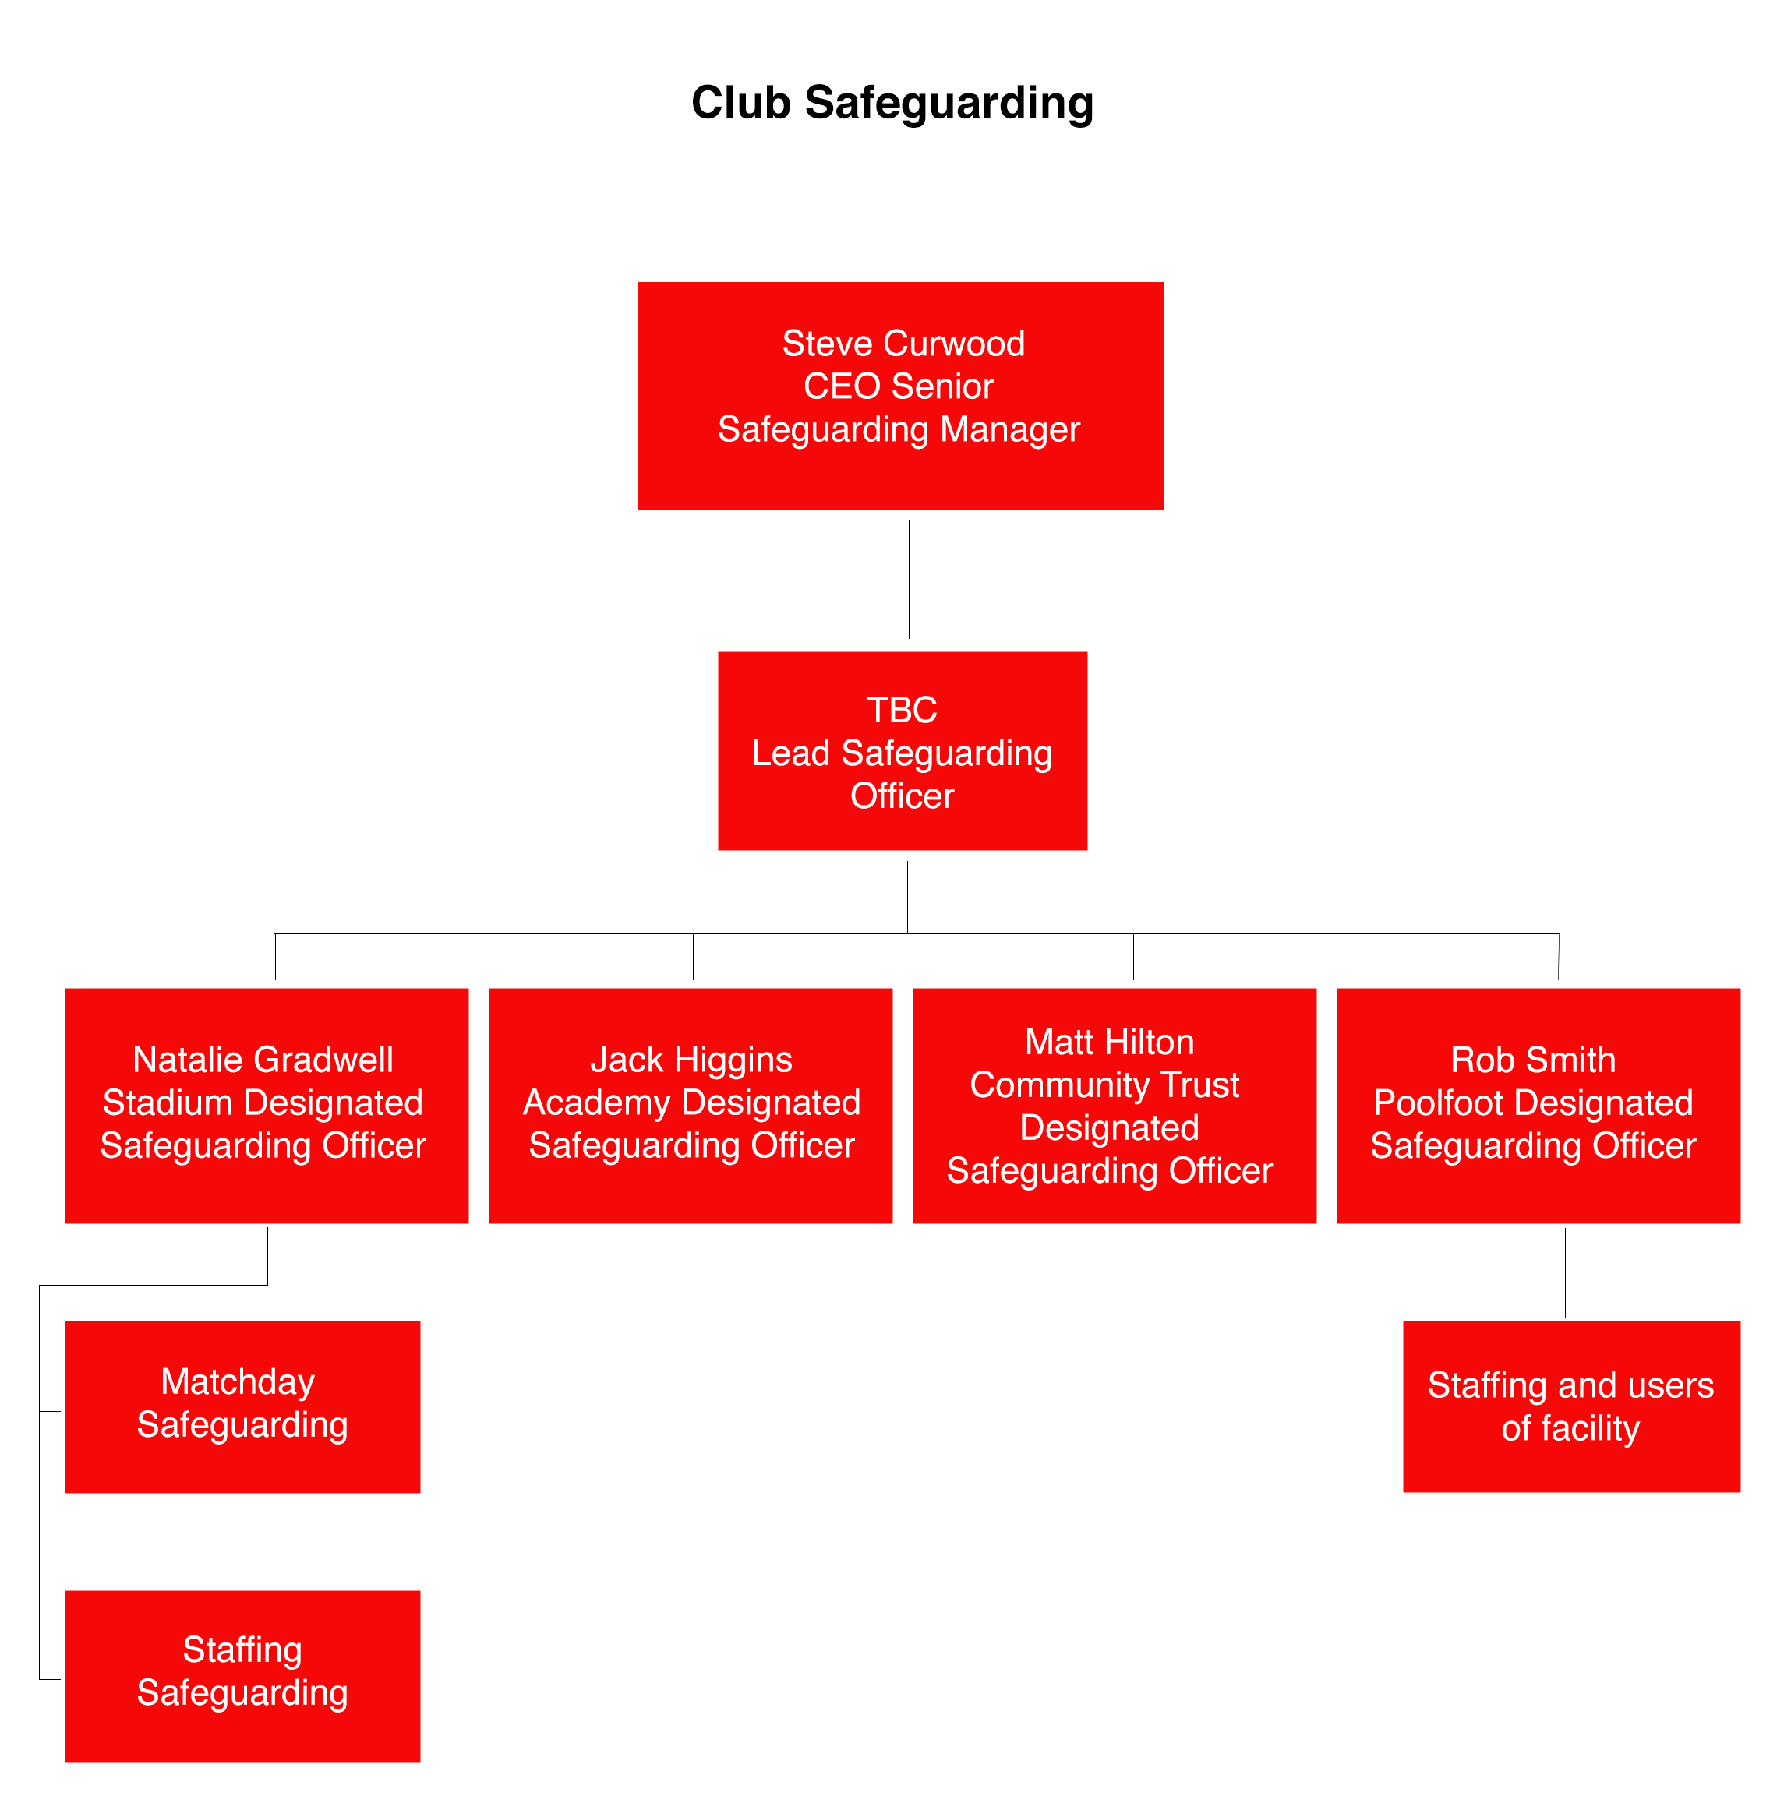

Community Trust Safeguarding:
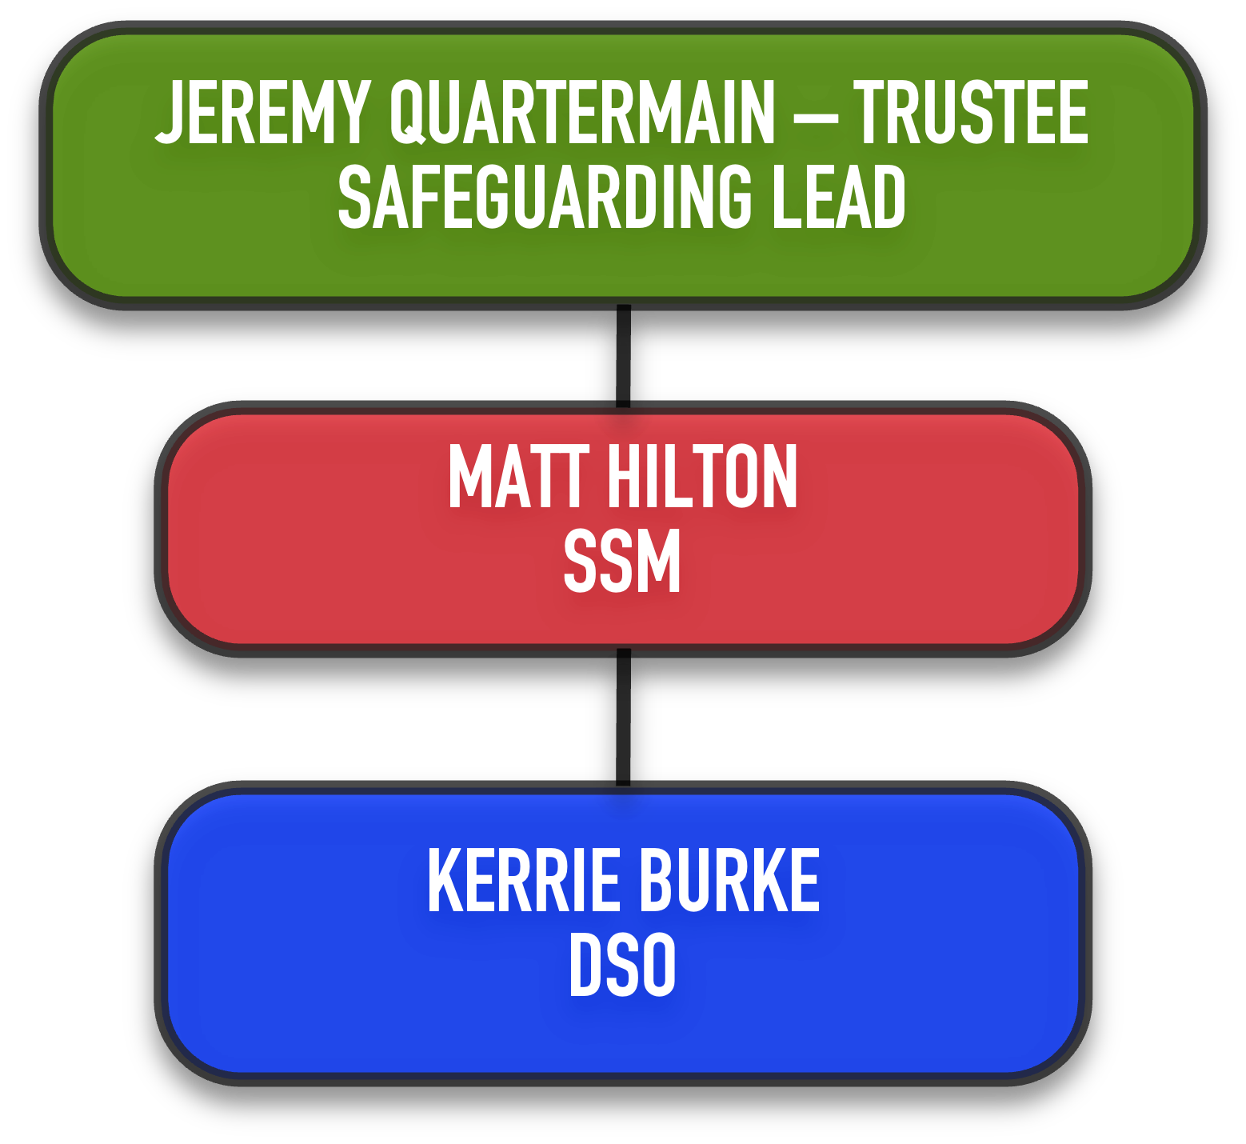

In the event of the SSM and DSO being unavailable, please contact Steve Curwood Senior Safeguarding Manager & FTFC CEO steve.curwood@fleetwoodtownfc.com mob 07773 027706
15 Complaints procedure
15.1 The organisation has a complaints procedure available to all staff, volunteers and trustees.
16 Recruitment procedure and DBS checks
16.1 The organisation operates procedures that take account of the need to safeguard and promote the welfare of Adults at Risk, including arrangements for appropriate checks on new staff, volunteers and trustees where applicable.
16.2 As part of the Trust’s safer recruitment and selection process, all positions of
employment are assessed as to whether they involve working with Adults at Risk.
This includes staff, volunteers, sessional workers and Trustees who may have access
to confidential information.

16.3 Where positions have been identified as working with Adults at Risk, subsequent
offers of employment, or acceptance as a volunteer, are subject to satisfactory
DBS checks for working with adults and two suitable references.

16.4 Where a negative disclosure is received, the potential employee, volunteer or Trustee
will not be allowed to work with Adults at Risk unsupervised and each case will be
considered relative to that individual following the Safer Recruitment and Ex-
Offenders Policies.

16.5 All partner agencies will be expected to follow, and be able to show, that proper
Safeguarding practices are carried out within their organisation. When working in
partnership on programmes and the Trust is the lead partner, our recruitment and
checking procedures will be followed.
17 References, internet links and further sources of information
17.1 ‘No Secrets’ report
17.2 The first national policy developed for the protection of vulnerable adults, for use by all health and social care organisations and the police. It introduced guidance around local multi-agency arrangements and was issued under Section 7 of the Local Authority Social Services Act 1970. Its implementation is led by local authorities with social services responsibilities.
17.3 Action on Elder Abuse (AEA) is a charity working to protect, and prevent the abuse of, vulnerable older adults.
http://www.elderabuse.org.uk
17.4 The Centre for Policy on Ageing was established in 1947 by the Nuffield Foundation with a remit to focus on the wide-ranging needs of older people
http://www.cpa.org.uk/index.html
17.5 Should any incident occur that impacts upon an adult at risk’s safety and welfare then an internal audit process would be immediately implemented.
Recording form for safeguarding concerns
Recording Safeguarding Concerns Form
Staff, volunteers and regular visitors are required to complete this form and pass it to their departmental Safeguarding Officer if they have a safeguarding concern about a Child or Adult at Risk they have come into contact with.
Full name of child | Date of birth | School/team/session | Your name and position

Nature of concern/disclosure
Please include where you were when a disclosure was made, what you saw, who else was there, what did the child/adult say or do and what you said.

Was there an injury? Yes / No Did you see it? Yes / No

Describe the injury:

Have you filled in a body map to show where the injury is and its approximate size?
Yes / No

Was anyone else with you? Who? Their position?

Who are you passing this information to?
Name:
Position:
Date:
Time:

Your signature:

Date:

Action taken by Safeguarding Officer:

Safeguarding Officer Signature:

Date referred to Head of Safeguarding, Welfare and Equality:

Action taken by Head of Safeguarding, Welfare and Equality:

Report/referral made to…?

Parents informed? Yes / No (If No, state reason)

Appendix C: Body Maps

Feedback given to…?

Head of Safeguarding, Welfare & Equality name:

Head of Safeguarding, Welfare & Equality Signature:

Date:

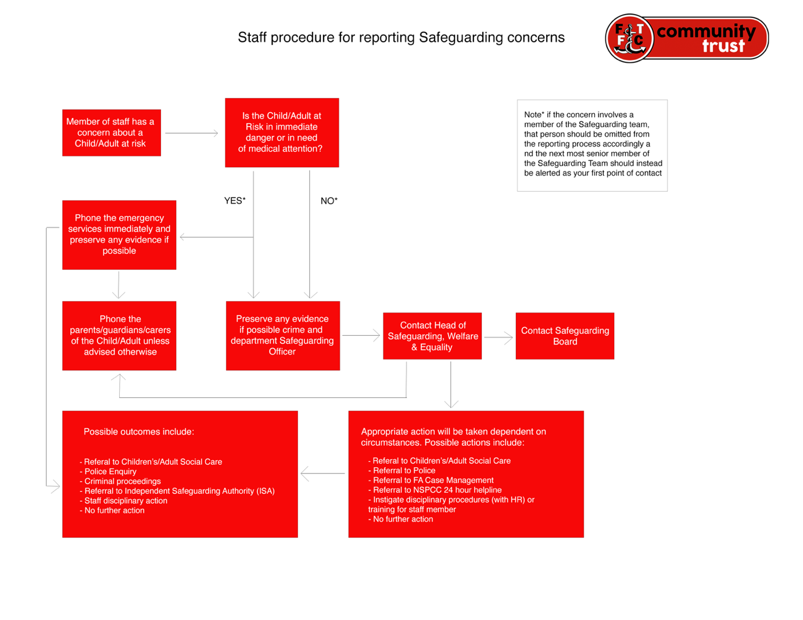

Version | 4.0
Date of Issue | October 2018
Last Review Date | March 2022
Next Review Date | March 2025
Lead | Jeremy Quartermain
Approved on | March 2022
Approved by | Board of Trustees
Published (where available) | FTFCCT Teams
Version History (details of changes made, when and by who)
Amended, edited by Jeremy Quartermain & approved by Trustees.

Signed: Name: PETE MURPHY

Role: Chair of Trustees

Dated: March 2022

