Safeguarding Children Policy

Contents Page

COMMUNITY TRUST COMMITMENT TO SAFEGUARDING 2-3

KEY SAFEGUARDING TERMINOLOGY AND DEFINITIONS 4-5

SAFEGUARDING CHILDREN POLICY 6-16

GUIDELINES IN THE EVENT OF A CONCERN 17

OUR RESPONSIBILITIES IN 5 STEPS 18

RECOGNISE – TYPES, SIGNS AND SYMPTOMS OF ABUSE 18-26

RESPOND – RESPONDING TO A REPORT OR SUSPICION 27-28

NON-RECENT ABUSE 28-31

REPORT – REPORTING POOR PRACTICE OR ABUSE 32-34

RECORD – RECORDING ALLEGATION OR SUSPICIONS 34

REFER – LOCAL AUTHORITY, FA AND PREMIER LEAGUE REFERRALS 35-41

APPENDICES:

APPENDIX A: STAFF PROCEDURE FOR REPORTING SAFEGUARDING 43
CONCERNS

APPENDIX B: RECORDING SAFEGUARDING CONCERNS FORM 44

APPENDIX C: SAFEGUARDING BODY MAPS 45-46

APPENDIX D: ACTION TAKEN WHEN A CHILD IS REFERRED TO LOCAL 47
AUTHORITY CHILDREN’S SOCIAL SERVICES

Community Trust Commitment to Safeguarding

Statement from Director of Community and Education:

Fleetwood Town FC Community Trust is committed to safeguarding, as far as is reasonably practicable, children, young people and vulnerable groups. The Trust aims to create an atmosphere where everyone feels valued, safe and have their voices heard.
The Trust expects all staff, players, volunteers, contractors, partners and guests to share this commitment and understand that everyone has a responsibility for safeguarding, to be alert and to report any concerns about the welfare of any child, young person or adult at risk to the Trust.
The Trust is committed to ensuring that:

- 'Every child has the right to protection from abuse and exploitation'
- The safety and welfare of children, young people and adults at risk whilst under the care of the Trust is paramount.
- listen to ALL children and adults at risk and take account of their wishes and feelings, both in individual decisions and in the development of services
- All children, young people and adults at risk that engage with the Trust, regardless of age, culture, social background, disability, gender, language, racial origin, religious belief and/or sexual identity have the right to safety and protection from abuse or harm.
- All suspicions, reports and/or allegations of abuse will be taken seriously and investigated thoroughly and may involve appropriate local authority teams where necessary.
- Appropriate action is taken if/when necessary following any investigation of reported poor practice.
- Recognises and accepts its responsibility for the safety and well-being of those children and young people who come within the care of the organisation and its staff, volunteers, board member and trustees of FT community Trust.
- Accepts its responsibility in the belief that the welfare and protection of children and young people is paramount, and everyone responsibility. The Trusts policy is endorsed by the board of trustees at Fleetwood Town Community Trust.
- Systems are in place that will prevent or minimise the risk of abuse occurring within the organisation. As an integral part of this process, The Trust will ensure that all children and young people who train with The Trust will have access to Designated Persons and a complaints procedure. In all Safeguarding issues, the Trust will work under the guidance of the Local Safeguarding Children Board, Football Association (FA) the English football League/Trust. The safeguarding DSO and the SSM hold meeting the minutes in form the board/trustees of any concerns. The board/ trustees have endorsed this policy. The policy will be reviewed annually or within 4 weeks of any safeguarding incident or legislative change, the Trust will have in place arrangements that reflect the importance of safeguarding and promoting the welfare of children, including a clear line of accountability for the commissioning and/or provision of service designed to safeguard and promote the welfare of children. A senior member at board level will take leadership r

responsibility for the Club’s safeguarding arrangements, Steve Curwood, SSM and Club CEO.

As a measure of the Trust’s commitment to safeguarding, a dedicated and trained Safeguarding team will implement, maintain, and embed best practice across all areas of operation.
The Safeguarding policy will also be continually monitored and subject to review annually or following any incident or near miss of a safeguarding nature.

Signed on behalf of Fleetwood Town FC Community Trust

Jeremy Quartermain – (Trustee)

Safeguarding lead:

Signature:

3.10.2020

Key Safeguarding Terminology and Definitions:

Child/Children – defined by law as a person aged under 18 years of age. However, a person aged 14 – 18 years of age will be referred to as a ‘Young Person’.

The Club – refers to Fleetwood Town Football Club, Highbury Stadium and Poolfoot Farm, its workforce and all activities undertaken by the organisations at these premises. In certain circumstances it may also refer to third parties with an entrusted responsibility for delivering club-supported activity.

The FA – refers to the Football Association, the National Governing Body for Football in England.

FTFCCT – refers to Fleetwood Town Football Club Community Trust

Harm – the ill-treatment of an individual or impairment of their welfare due to acts of abuse or inappropriate behaviour, including witnessing third party abuse or inappropriate behaviour.

Local Authority – refers collectively or individually when named to the district, borough, city and county councils that are responsible for governance of the county of Lancashire in which the Trust operates. Specifically, but not exclusively, these include Wyre Borough Council and Lancashire County Council.

Local Authority Safeguarding Board – refers to the department within each local authority responsible for providing guidance, training and governance on all safeguarding matters within their area of governance.

The NSPCC – refers to the National Society for the Prevention of Cruelty to Children (NSPCC), a charity that actively campaigns for and works within child protection in England, Wales, Northern Ireland and the Channel Islands.

The Premier League – refers to the organisation responsible for governance and administration of English Football’s highest ranked league, of which Fleetwood Town FC are current members.

Safeguarding – preventative and reactional measures taken by the Trust to ensure that: the risk of harm or mistreatment of vulnerable groups is minimised; the health or wellbeing of vulnerable groups is not impaired whilst engaging in Trust activities and an environment exists that supports the best possible outcomes or life chances for vulnerable groups.

Safeguarding Team – the collective group of staff within the Club and Trust that have a professional responsibility for the safeguarding of vulnerable groups. Specifically, this is made up of the Lead Trustee for Safeguarding (LTS), Senior Safeguarding Manager (SSM) and Designated Safeguarding Officers for areas of work (DSO).

Staff – refers to persons employed by and receiving payment for services from the Trust. This is irrespective of the length or nature of their contract.

The Training Ground – The Club’s external independent site at which the day-to day training of the Club’s First Team & Under 21 Team takes place; BTEC Education; Holiday Sports Camps; Community Pitches and Tournaments.

Volunteers – persons who freely offer their skills and expertise or take part in a task, event or enterprise with the Trust at their own expense in term of time and/or resources.

Adult(s) at Risk – an adult (person aged 18 or over) who is receiving one of the following services: health care; relevant personal care; social care work; assistance in relation to general household matters by reason of age, illness or disability; relevant assistance in the conduct of their own affairs or conveying (due to age, illness or disability in prescribed circumstances).

Vulnerable Group(s) – the collective term used when talking about or referring to Children, Young People and Adults at Risk as a whole.

Welfare – the general health, happiness and fortunes of individuals and the humanitarian aspects of their life including personal needs, social interactions and physical/ psychological and emotional development.

Workforce – refers to the combined entity created when staff, volunteers and/or third-party contractors are deployed together to work on a Trust activity, event or enterprise.

Young Person/People – defined by the Trust as a person aged between 14 and 18 years of age.

Safeguarding Children Policy

1. Mission Statement:

  - Fleetwood Town FC Community Trust acknowledges and accepts a responsibility for the wellbeing and safety of all children, young people and adults at risk who come under their care whilst engaging with the Trust or utilising their facilities. The Trust is committed to delivering a Safeguarding Programme that ensures the wellbeing of children, young people and adults at risk is maintained at all times through effective induction, training, promotion and embedding of best practice amongst staff, volunteers, partner organisations and participants.

2. Rules, Regulations and Guidance

2.1 The Trust is governed by the rules and regulations set out by several key governing agencies including the Government, Football Association, Premier League, NSPCC Child Protection in Sport Unit (NSPCC CPSU) and the Department for Education, amongst others.

2.2 The content of this policy is underpinned by legislative and statutory documents and policies as presented by these key governing agencies.
Key documents underpinning this policy include:
- ‘The Children Act’ (2015) – HM Government
- ‘Every Child Matters – Change for Children’ (2003) – HM Government
- ‘Safeguarding Vulnerable Groups Act’ (2006) – HM Government
- ‘Working Together to Safeguard Children’ (2015) – HM Government
- ‘Keeping Children Safe in Education’ (2020) – HM Government
- ‘Human Rights Act’ (1998) – HM Government
- ‘No Secrets’ (2000) – Department of Health (DoH)
- ‘Standards for Safeguarding and Protecting Children in Sport’ (2005) – NSPCC CPSU
- ‘Premier League Rules: Section S’ (2016/17 season) – The Premier League (PL)
- ‘Guide for Safer Working Practice’ (April 2015) – PL
- ‘Working Together to Safeguard Football- Policy and Procedures’ (2014) – The Football Association (FA)

2.3 The Trust is fully committed to ensuring that the best practice recommended by these pieces of legislation, policies and guidelines is implemented, maintained and embedded within the day to day working practice of all the workforce, at all times. The Trust is also fully committed to a ‘continually improving’ approach to Safeguarding.

2.4 In keeping with these commitments, the Trust recognises its responsibility to maintain regular dialogue with the Lancashire Safeguarding Children Board and local Safeguarding Boards to both report any Safeguarding concerns/ record incidents for monitoring and to receive support in training, development and sharing of best practice.

3. Scope

3.1 This policy recognises that children and young people are particularly vulnerable to harm due to their potential inability to self-determine, depending on their age and experiences, between what is legally, morally or ethically right or wrong. As a result, this policy supports the Safeguarding Team in ensuring that the Trust reacts to the occasions where proactive and preventative work has failed and where harm or abuse has occurred by acts of commission or omission as defined by statutory guidance, legislation and the law.

3.2 This policy also recognises that whilst children and/or young people may themselves consent to activities they undertake (inclusive of sexual activities), there are clear statutory guidelines to follow on determining age and ability to consent. The Trust will report any incidents/ allegations to the relevant agencies, regardless of consent being given. In line with statutory, legislative and legal guidelines, a criminal offence may have been committed and the Trust recognises its responsibilities for reporting such incidents.

3.3 The Safeguarding Team also has a focus to review any reports, allegations or incidents and put safeguards in place to minimise the re-occurrence of harm to any other child, young person or adult at risk.

3.4 As part of this, the Safeguarding Children Policy will be reviewed annually or whenever there is an organisational change, the Trust implements a new activity or service which involves contact with children and/or adults at risk; change in legislation or following any learning outcomes from safeguarding incidents, concerns or allegations.

3.5 The Trust informs all participants and beneficiaries through various social media platforms and requests can be made directly to the Safeguarding Manager for copies of all safeguarding policies and procedures. A copy of the safeguarding policy for children and vulnerable adults can downloaded via the Trust website www.fleetwoodtownfcct.com

4. Aims and Key Principles

4.1 Whilst it is hoped that proactive preventative work, including vetting, training and providing clear policies and best practice guidelines to the workforce and participants are sufficient to safeguard all children, young people and adults at risk, the Trust recognises that it has a responsibility to embed a proactive approach into all aspects of daily working practice.

4.2 The aims of this policy are therefore:
- To safeguard all children and young people who interact with the Trust
- To demonstrate best practice in the area of safeguarding children and young people
- To develop positive and proactive programmes that enable all children and young people to participate in a safe environment
- To outline and support a clear system that effectively prevents, intervenes and processes safeguarding matters should they arise
- To promote ethical standards throughout all activities and programmes.

4.3 The key principles underpinning this policy are:
- The child/ young person’s welfare is, and must always be, the paramount consideration
- All children and young people have a right to be protected from harm and abuse regardless of their age, gender, disability, culture, language, racial origin, religious beliefs or sexual identity
- All allegations of abuse will be taken seriously and responded to efficiently and appropriately
- To encourage parents/carers to be involved in a relationship with the Trust
- To ensure that parents/carers, coaches and other adults who come into contact with children and young people participating in Trust activities and programmes provide positive role models of behaviour and attitude.

4.4 The below Trust policies and best practice guidelines support the Safeguarding Children Policy and should be read in conjunction with this policy to provide further understanding and guidance.

4.5 All policies can be found electronically on the Trust Shared Drive or hard copies in the Community Trust Office.

- Code of Conduct – See staff handbook
- Safeguarding Adults at Risk Policy
- Safer Working Practice Policy – See Health & Safety Policy
- Engaging with Vulnerable Groups on Club Premises Policy
- Equality and Diversity Policy
- Health and Safety Policy
- Staff Anti-Bullying Policy
- Staff Harassment Policy
- Safer Recruitment Policy
- Whistleblowing Policy
- Secure Record Keeping and Data Storage
- Data Protection Policy
- Use of Photography and Images Policy
- Social Media and Safer Internet Policy
- Spectator Safety Policy
- Complaints Policy and Club-wide Disciplinary Procedure
- Trips, Tours and Travelling Away with U18’s Policy
  - Providing accommodation for children and young people staying away from home policy
- Club-wide Code of Ethics
- Lone Working Policy
- Recruitment of Ex-Offenders Policy
- EFL Critical incident Procedures
- NCS Critical incident Procedures

5. Key Personnel

Safeguarding Board:

The Safeguarding Board is the governing panel for all Safeguarding issues within the Club. It consists of 5 members of staff, (the CEO and SSM for the whole Club, and 4 DSOs for the stadium, Academy, Community Trust and Poolfoot Farm operations) who meet regularly to discuss matters arising and how safeguarding should be taken forwards within each department of the Club. The board also invites a member of the HR department in an advisory capacity. The board is also responsible for the handling and/or escalation of serious safeguarding issues where matters cannot be handled solely by the SSM. Members of the Safeguarding Board also report directly to the SSM of the Club and actively update the Club’s Safeguarding board and wider Heads of Department in matters arising, best practice and legislation changes when necessary. The group meets monthly at present and will review this schedule if required.

Lead Trustee for Safeguarding (LTS) – Mr Jeremy Quartermain (Head Teacher, Rossall School).

Roles & Responsibilities:
5.1 Member of the Board and governing panel for all safeguarding issues within the Trust who meet regularly to discuss matters arising and how safeguarding should be taken forward within each area of the Trust. Also responsible for handling and/or escalation of serious safeguarding issues where matters cannot be handled solely by the Head of Safeguarding. Advises on best practice and changes in legislation where necessary.

Senior Safeguarding Manager (SSM) – Mr Matt Hilton (Director of Community and Education)

Roles & Responsibilities:
5.2 The Head of Safeguarding is responsible for maintaining the safety and wellbeing of all children, young people and adults at risk when engaged in Trust activities and programmes. Responsible for writing, implementing and updating all safeguarding policies, procedures, best practice, training and development of staff and handling of all allegations or escalated reports of poor practice.

5.3 The SSM is also responsible for the Trust’s Disclosure and Barring Service (DBS) process and checking criminal records and the hiring of ex-offenders.

5.4 The SSM is responsible for actively working with local authorities, the Premier League and the Football Association to embed a vulnerable group safeguarding culture within the Trust.

5.5 The SSM is a member of the parent club safeguarding board and is responsible for liaising with the LTS and the DSO on all safeguarding board matters.

Designated Safeguarding Officer (DSO) sports activities and programmes – Ms Laura Went (Senior Lecturer)

Roles & Responsibilities:
5.6 The DSOs work across various departments within the Trust to provide hands- on implementation of safeguarding policies and procedures for children, young people and adults at risk within their area of work. It is their role to support the SSM in embedding best practice, reporting concerns, relevant changes in legislation in their area of work, safer recruitment.

5.7 Meet regularly with the SSM to assist with record keeping, case/incident handling and policy/practice review where appropriate.

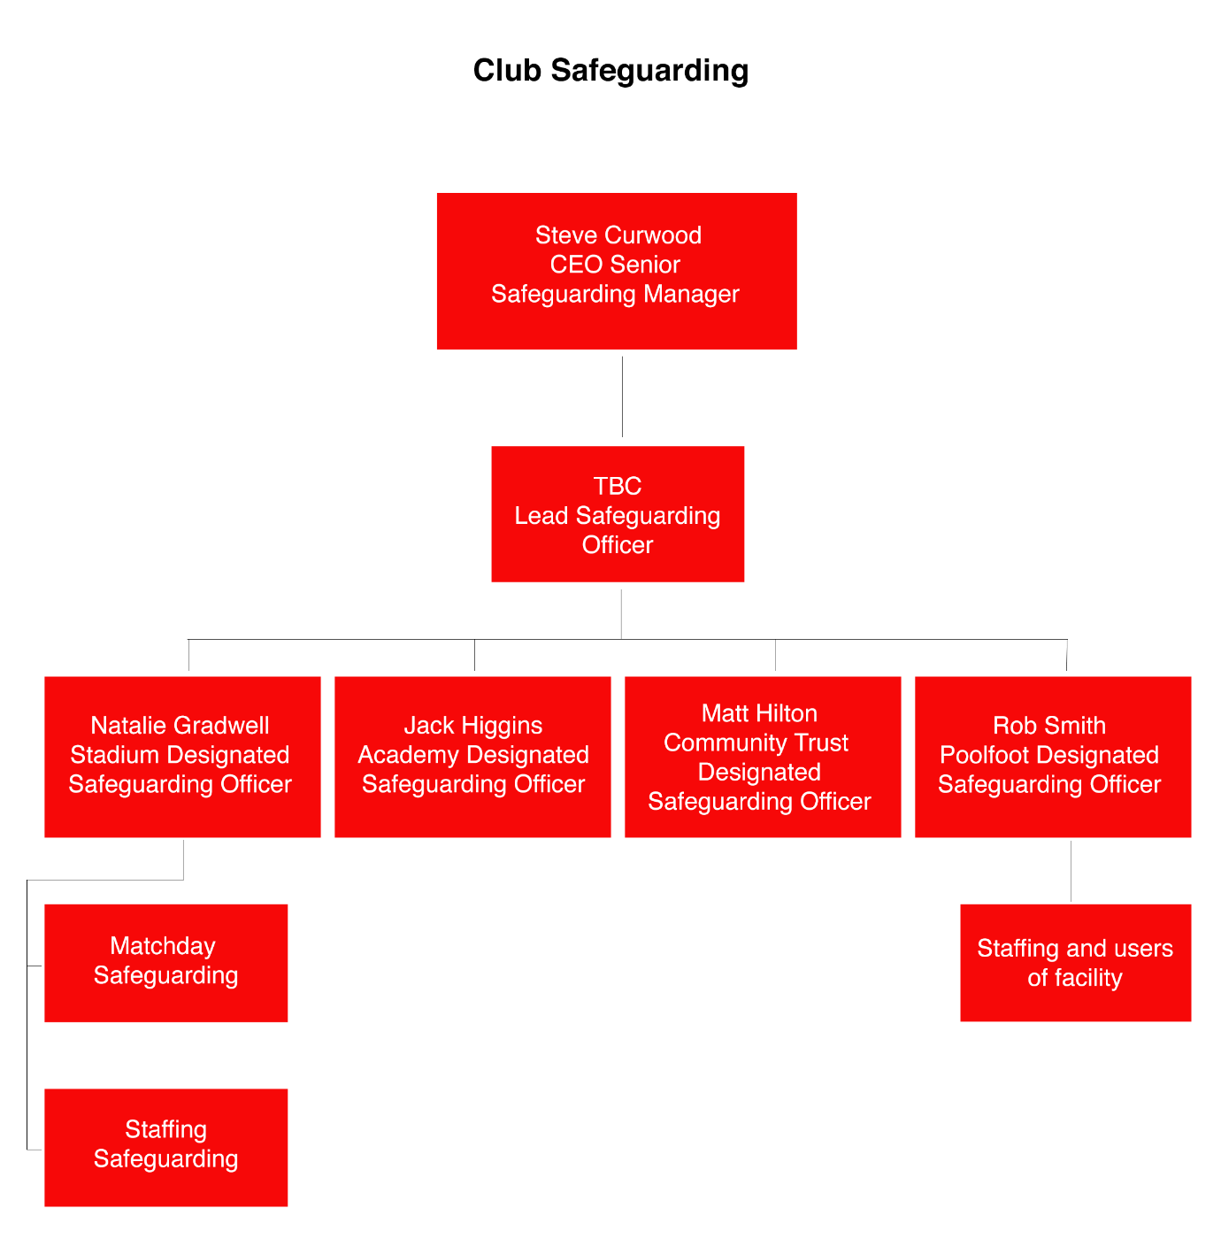

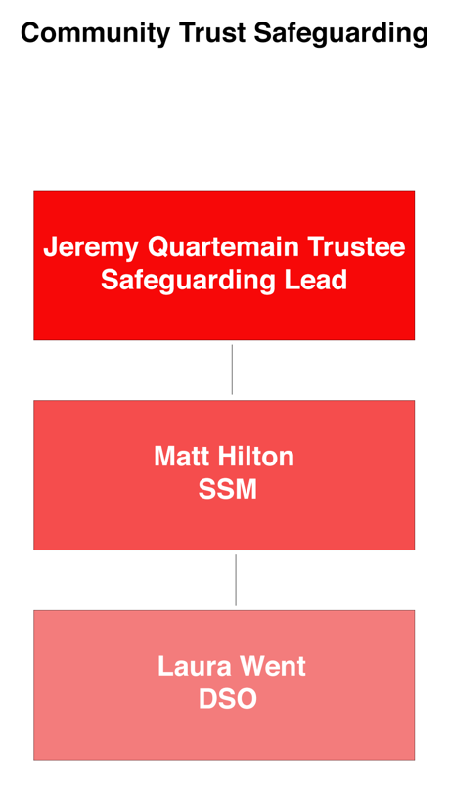

Safeguarding Team Contact Details:

Board of Trustees
Safeguarding Lead
Jeremy Quartermain
T: 01253 774201
E: Head@rossall.org.uk

Head of Safeguarding
Senior Safeguarding Manager
Matt Hilton
Chief Executive
T: 01253 208442
M: 07794 941021
E: matt.hilton@fleetwoodtownfc.com

Designated Safeguarding Officers
Laura Went
Senior Lecturer
T: 01253 208442
M: 07584 199444
E: laura.went@fleetwoodtownfc.com

In the event of the SSM and DSO being unavailable, please contact Steve Curwood Senior Safeguarding Manager & FTFC CEO steve.curwood@fleetwoodtownfc.com or mobile 07773 027 706
6. Best Practice Procedures and Guidelines
As part of the embedding process, the Trust will also support the above policies through incorporating numerous best practice procedures and guidelines in, but not limited to, the following areas:

6.1 Recruitment:
6.1.1 The Trust need to be vigilant in the recruitment and selection of their staff. Abusers will target such organisations and be extremely adept at presenting themselves as caring and trustworthy individuals. Indicators of abusive behaviour can emerge through inappropriate attitudes or inconsistent reactions. A vigorous recruitment and selection process provides important opportunities to deter and prevent offenders from gaining access to children and young people through their work. See Safer Recruitment and Recruitment of Ex-Offenders policies for further guidance.

6.1.2 As part of the Trust’s safer recruitment and selection process, all positions of employment are subject to assessment to ascertain whether the position involves working with children or young people. This will be carried out by the Director of Community and Education.

6.1.3 Where positions have been identified as working with children or young people, subsequent offers of employment are subject to a satisfactory Disclosure and Barring Service (DBS) and appropriate references.

6.2 Disclosures and DBS Checking:
6.2.1 The Trust is registered with the DBS who provide a disclosure service for organisations. Disclosures enable employers to undertake more thorough recruitment and selection procedures for positions which involve working with children and young people.

6.2.2 DBS disclosures are processed for the Trust by the online company Online Disclosures. Through their service there are 3 levels of checks staff can be asked to undertake: a Basic Disclosure, Standard Disclosure and an Enhanced Disclosure. The level of check staff undertake will be dependent on their role and the level of contact they will have with children or young people for the purpose of their job role.

The process for DBS disclosures is:
6.2.3 New Appointments:
6.2.3.1 Each different job role within the Trust will involve different levels of contact and engagement with children and young people. All staff who are offered a position which involves working within regulated activity with children for more than six weeks, or alone, will be required to undertake an Enhanced Disclosure check.

6.2.3.2 All employment offers are subject to the outcome of this screening process and where applicable, this is set out in their offer of employment. Until such time as their Disclosure Certificate has been seen/ sanctioned by the Head of HR and/or the Head of

Safeguarding, the new member of staff will not be allowed to commence employment or left unsupervised with children or young persons.

6.2.3.3 The Trust is committed to the equal opportunities of its staff and therefore if a positive Disclosure is not received it will not result in an instant dismissal from employment. Should a negative Disclosure be received, the Trust’s ‘Safer Recruitment Policy’ will be applied.

It is important to note, in respect to this process, each case will be treated individually, and any action required will be subject to the details of this investigative procedure only.

6.2.4 New Appointments who already have a Disclosure Certificate:
6.2.4.1 If a new member of staff has been checked by their previous employer, regardless of the age of the disclosure, they are still required to undertake another check.

6.2.5 Existing Staff:
6.2.5.1 All staff who have responsibilities for leading activities, or who spend a significant part of their job in contact with children and young people have been vetted by the Trust.

6.2.5.2 In accordance with the best practice guidelines offered by DBS, all staff complete a Disclosure check every 3 years.

6.2.6 Volunteers:
6.2.6.1 Volunteers play an important role within the activities of the Trust and their contribution is valued and significant. All volunteers who work with children and young people and/ or have access to confidential information are required to undertake a Disclosure check in the same capacity as if they were employed members of staff.

6.2.6.2 It should be highlighted that, in order to accommodate the administration costs of this process, a volunteer disclosure will only be undertaken if a commitment is made by the volunteer to undertake work on any given programme for a period lasting more than six weeks. If volunteering for less than six weeks the volunteer will not require a DBS disclosure. As best practice a Risk Assessment for their involvement will be undertaken by the programme or activity leader and all involvement of the volunteer will be supervised at all times by an employed member of staff with the agreed level of DBS disclosure.

6.2.6.3 For volunteers undertaking ‘work experience’, a DBS disclosure will not be undertaken due to the length of the placement being typically less than six weeks. In this situation the same Risk Assessment and supervision procedures outlined above should be applied. Should the ‘work experience’ last for the duration of more than six consecutive weeks, an assessment will be made to whether a DBS disclosure should be undertaken.

6.2.7 Agency or Supply Staff:
6.2.7.1 The same standards apply to agency or supply staff. Supply agencies should undertake DBS checks for their staff but, it is the Trust’s responsibility to check and record that this has been done.

6.2.8 Staff and Volunteers from Overseas:
6.2.8.1 In the case of staff and volunteers who have lived abroad, if in the opinion of the Head of Safeguarding the DBS disclosure is unlikely to provide sufficient information, based on how long the individual has been living in the UK, then other checks must be completed prior to the individual starting work or volunteering. This may be in the form of certificates of good conduct from relevant embassies or police forces as appropriate.

6.3 Staff Induction:
6.3.1 During the induction process of new staff and volunteers this policy and specific guidance is given out, discussed and signed off as read and understood. Key to this process is staff understanding the expectations of them from the Trust and to familiarise themselves with the policies and procedures they must adhere to. All related policies and guidance referred to are also included in staff induction and are an integral part of the Staff Handbook. At induction stage, staff and volunteers will have any training needs identified.

6.4 Staff/Volunteer Training:
6.4.1 All staff and volunteers working in direct contact with children and/or young people will be required to complete Safeguarding training before being able to commence their duties unsupervised. This must be completed within the first month of commencing their employment. The Trust takes a personalised approach to this depending on the level of contact with children/ young people the job role requires and the level of management of programmes and staff.

6.4.2 Annually, the Trust delivers in house safeguarding workshops, which includes: any policy update, Prevent and Mental Capacity Act. Furthermore, staff and volunteers complete an FA safeguarding Children workshops every 3 years.
6.4.3 Details of those satisfactorily completing these courses is held on file by the Head of Safeguarding and reviewed during staff six monthly appraisals and Continuing Professional Development (CPD).

6.5 Health and Safety:
6.5.1 The Trust’s Health and Safety Policy gives guidance about ensuring the safety of children and young people to those whose roles involve working with them on a regular basis. Where a child or young person is involved in an activity, a risk assessment must take account of their particular vulnerabilities whilst they are in the Trust’s care. The risk assessment should set out what arrangements are in place for their care and supervision, examples are kept with the Head of Safeguarding and on the shared drive. 6.5.2 These risk assessments are carried out for educational activities, employability programmes, NCS, trips and events as well as physical activities.

6.6 Confidentiality and Data Protection:
6.6.1 The Trust takes the protection of data seriously. Often, if a Safeguarding incident has taken place, ‘Sensitive Data’ is generated which must be treated accordingly. As part of the Trust’s Data Protection Policy, staff understand the importance of confidentiality and how to record, process and store sensitive data and the further processes surrounding

effective data handling. The Trust’s Confidentiality and Data Protection Policy is in line with current legislation and available as a support policy.

6.7 Parental Consent:
6.7.1 For all relevant activities the Trust will make every effort to obtain parental consent for children and young people’s (under 18) participation using a parental consent form which includes medical details and emergency contact numbers. Whilst every effort will be made to obtain such consent, it should be noted that in some circumstances, due to the nature of the work carried out or the timescales involved, obtaining parental consent for activities may not always be possible. In such circumstances the Trust will act in accordance with best practice, statutory, legislative legal guidance.
6.7.2 If a child or young person is deemed at Risk of Harm, the Trust reserves the right to act in the best interests of the child or young person without prior parental consent, although if obtaining consent is possible and deemed external to the risk posed, it is considered best practice.

6.8 Activities for Disabled Persons:
6.8.1 All activities carried out for disabled persons are carried out under the guidelines of the Equality Act (2010). All reasonable adjustments will be made to ensure that no-one is excluded from activities due to a disability and that everyone has their voice heard.

6.9 Working with Partner Organisations:
6.9.1 Working in Educational Institutions:

6.9.1.1 The Trust are committed to using the power of sports to encourage children and young people to enjoy the benefits of sport and healthy living and run coaching sessions within local nurseries, schools and education centres.

6.9.1.2 It is the responsibility of the nursery, school, college or education centre to obtain parental consent for activities and carry out the relevant site-based risk assessments before an activity takes place and each site is expected to carry its own Public Liability Insurance. The Trust will produce an activity-based risk assessment for each activity undertaken at the site and will produce a further pre-session spot check of activity immediately prior to the event taking place. The Trust also has its own Public Liability Insurance.

6.9.1.3 The Trust expects nurseries, schools, colleges and education centres to have their own Safeguarding personnel, policies and best practice in line with government legislation and OFSTED guidelines. As best practice, the educational institution may also be requested to share their policies and practices with the Trust as means of evidencing their best practice procedures and further ensuring the safety of the participants involved. The above information is set out in a written Service Level Agreement (SLA) with the educational institution prior to activities taking place. The Trust reserves the right to revert to its own safeguarding policies and procedures in the event of concern or lack of clarity.

6.9.2 Working in the Community:
6.9.2.1 The scope and nature of the Trust’s work will also engage with children and young people from the local communities and quite often, organised events will be based externally to the Club and Training Ground and will require access to local facilities and assistance from partner staff and volunteers; for example, delivery of the National Citizen’s Service Programme (NCS).

6.9.2.2 Where events take place at external community venues it is the responsibility of the venue management to carry out the relevant site-based risk assessments. The Trust accepts responsibility for undertaking activity-based risk assessments and pre-session checks. In terms of Safeguarding, where external venues have Safeguarding policies and procedures in place, it is requested that these are shared as best practice.
6.9.2.3 If venues do not have any, or as robust Safeguarding systems, the Trust will request the adoption of their own Safeguarding policies and procedures for the duration of the event or work being undertaken.

6.9.3 Working with Funders, Sponsors and other External Partners:
6.9.3.1 The Trust will always act as the lead Safeguarding party when working with funders, sponsors and external partners if it is the lead partner in delivery. However, best practice will be shared and adopted from other partners if it is more appropriate for the work being undertaken.

6.9.3.2 When working with funders, sponsors and external partners the Trust is committed to establishing an agreed set of Safeguarding standards for all co-operative work. This generally constitutes agreement in a contract or service level agreement of the minimum standards expected.

6.10 Code of Conduct

All participants on Trust programmes are issued with a copy of the Trusts code of conduct. The participants are expected to know, understand and exhibit what is expected of their behaviour.

7. Guidelines in the Event of Concern
7.1 Although the Trust is committed to doing the utmost to safeguard children and young people from harm, there may be an occasion when concern is raised over the treatment of a child or young person.

7.2 ‘Child abuse’ and ‘neglect’ are generic terms encompassing all ill treatment of children or young people, as well as the cases where the standard of care does not adequately support the child or young person’s health or development. Children or young people may be abused or suffer neglect through the infliction of harm, or through the failure to act to prevent harm. Harm may occur anywhere in a Trust activity or in a family, institutional or community setting, and the perpetrator may or may not be known to the child or young person.

7.3 There are complex scenarios associated with the potential for harm. These include:

- Children or young people participating within or attending programmes/ activities delivered by Trust may be at risk of harm or abuse from other children or young people involved in the Trust activity or elsewhere in participants networks. Harm may be deliberate or result from not understanding the child or young person’s needs or feelings.

- Children or young people may be at risk of harming others in Trust activities either by deliberate behaviours or by failing to understand their responsibilities to others. On these occasions the child or young person may need help and support to manage their behaviour in a suitable way or may need to have certain responsibilities removed from them. Safeguards and/or risk assessments may need to be put in place to protect others. Where appropriate, acceptable behaviour contracts should be agreed with children and young people that include safeguarding expectations.

- Coaches, tutors, parents may also risk harming children or young people through failing to highlight information about or provide support for children or young people who have additional or different support needs to those of their peers when participating in Trust activities.

8. Our Responsibilities in 5 Steps
8.1 All members of staff employed by the Club must acknowledge the Club has a Safeguarding responsibility towards protecting all children it engages with. This responsibility can be summarised by the following 5 step process:

RECOGNISE RESPOND REPORT RECORD REFER

9. Recognise – Types, Signs and Symptoms of Abuse
9.1 Types of Abuse:
Abusive behaviour can be assessed on a scale from poor practice, to bad practice to abuse. Abuse cannot be easily measured as an action alone. Its severity will partly be defined by the:
- Vulnerability of the victim and the power differential
- Nature and extent of the abuse
- Length of time it has been occurring
- Impact on the individual or group
- Risk of it being repeated or becoming increasingly serious

At one end of the scale, there may be obvious signs and symptoms of abuse, but at the opposite end, the indicators may be very difficult to detect. Combinations of factors which individually might not give cause for concern could be much more worrying when considered together. The abuse may be committed by one individual against another or be institutional in that the whole organisation colludes in abusive practices either through ignorance or choice.

‘Every Child Matters – Change for Children’ (2003) identifies five main forms of abuse as follows; should you have any concern that abuse is occurring you should contact a Safeguarding Officer immediately.

9.1.1 Physical Abuse:
Physical abuse may involve hitting, shaking, throwing, burning or scalding, drowning, suffocating or otherwise causing physical harm to a child or young person. Physical harm may also be caused when a parent or carer fabricates the symptoms of, or deliberately induces illness in a child or young person.

9.1.2 Emotional Abuse:
Emotional abuse is the persistent emotional maltreatment of a child or young person such as to cause severe and persistent adverse effects on the child or young person’s emotional development. It may involve conveying to children or young people that they are worthless or unloved, inadequate or valued only insofar as they meet the needs of another person.
It may feature age or developmentally inappropriate expectations being imposed on children or young people. These include interactions that are beyond the child or young person’s developmental capability, as well as overprotection and limitation of exploration and

learning, or preventing the child or young person participating in normal social interaction. It may involve seeing or hearing the ill-treatment of another.
It may also involve serious bullying, causing children or young people to frequently feel frightened or in danger, or the exploitation and corruption of children or young people. Some level of emotional abuse is involved in all types of maltreatment of a child, though it may occur alone.

9.1.3 Sexual Abuse:
Sexual abuse involves forcing or enticing a child or young person to take part in sexual activities, including prostitution, whether or not the child or young person is aware of what is happening. The activities may involve physical contact, including penetrative (e.g. rape, buggery or oral sex) or non-penetrative acts. They may include non-contact activities, such as involving children or young people in looking at, or in the production of, sexual online images, watching sexual activities, or encouraging children or young people to behave in sexually inappropriate ways.

9.1.4 Neglect:
Neglect is the persistent failure to meet a child or young person’s basic physical and/or psychological needs, likely to result in the serious impairment of the child or young person’s health or development. Neglect may occur during pregnancy as a result of maternal substance abuse. Once a child is born it may involve a parent failing to:
- Provide adequate food, clothing and shelter (including exclusion from home or abandonment)
- Protect a child or young person from physical and emotional harm or danger
- Ensure adequate supervision (including the use of inadequate caregivers)
- Ensure access to appropriate medical care or treatment

9.1.5 Financial or material abuse:
The nature of the industry the Club/Charity operates in and the associated wealth some young people may be able to earn/accumulate, particularly in relation to their friends and peers, the potential for these players to be financially abused must be considered.
A definition of financial abuse in Child Safeguarding legislative and statutory guidance is difficult to find, however ‘No Secrets’ (2000) defines financial abuse as:

Financial or material abuse includes theft, fraud, exploitation, pressure in connection with wills, property or inheritance or financial transaction, or the misuse or misappropriation of property, possessions or benefits.

It may also include neglect of, or unresponsiveness to a child or young person’s basic emotional needs.

Due to the nature of the work the Trust undertakes, this policy recognises that when engaging in such activities those leading the activities will adopt a position of caring for children and/or young people for the duration of the activities. In such circumstances, neglect may take a sport specific form and may include staff, amongst other things, failing to:

- Provide adequate time for refreshments
- Failing to ensure participants are wearing appropriate clothing and protective equipment, are free from jewellery and are provided with appropriate, safe equipment.
- Undertaking sessions in inappropriate weather conditions
- Failing to ensure participant adhere to participation guidelines in terms of age and sex, player coach ratios and ability.

9.2 Other types of abuse we recognise
The Club/Charity also consider the following as types of abuse that, must be acted upon if suspected as taking place:

9.2.1 Bullying:
Bullying is not always easy to identify as no legal definition of bullying exists. However, for the purpose of this policy, it can be characterised as behaviour that is repeated with the intention of hurting someone either physically and emotionally often, but not exclusively, because of their race, religion, gender, or sexual orientation. Bullying can take many forms and includes physical assault, teasing, making threats, name calling cyberbullying (bullying via mobile phones or online using social media, networks and instant messengers). Institutional bullying can also take place which involves that above behaviours being demonstrated by several members of one particular institution to target specific individuals or groups of individuals. . Further guidance on Bullying can be found in the Club Anti-Bullying Policy.

9.2.2 Child Sexual Exploitation (CSE) and Child Criminal Exploitation (CCE):
Both CSE and CCE are forms of abuse and both occur where an individual or group takes advantage of an imbalance in power to coerce, manipulate or deceive a child into sexual or criminal activity. Whilst age may be the most obvious, this power imbalance can also be due to a range of other factors including gender, sexual identity, cognitive ability, physical strength, status, and access to economic or other resources. In some cases, the abuse will be in exchange for something the victim needs or wants and/or will be to the financial benefit or other advantage (such as increased status) of the perpetrator or facilitator. The abuse can be perpetrated by individuals or groups, males or 10 females, and children or adults. The abuse can be a one-off occurrence or a series of incidents over time and range from opportunistic to complex organised abuse. It can involve force and/or enticement-based methods of compliance and may, or may not, be accompanied by violence or threats of violence. Victims can be exploited even when activity appears consensual and it should be noted exploitation as well as being physical can be facilitated and/or take place online.

9.2.3 Peer on peer abuse
This is most likely to include, but may not be limited to:
• bullying (including cyberbullying);
• physical abuse such as hitting, kicking, shaking, biting, hair pulling, or otherwise
causing physical harm:
• sexual violence, such as rape, assault by penetration and sexual assault:
• sexual harassment, such as sexual comments, remarks, jokes and online sexual
harassment, which may be stand-alone or part of a broader pattern of abuse:
• ‘up skirting’, which typically involves taking a picture under a person’s clothing
without them knowing, with the intention of viewing their genitals or buttocks to
obtain sexual gratification, or cause the victim humiliation, distress or alarm:
• sexting (also known as youth produced sexual imagery); and
• initiation/hazing type violence and rituals.

9.2.4. Serious violence
All staff should be aware of indicators, which may signal that children are at risk from, or are involved with serious violent crime. These may include increased absence from college, a change in friendships or relationships with older individuals or groups, a significant decline in performance, signs of self-harm or a significant change in wellbeing, or signs of assault or unexplained injuries. Unexplained gifts or new possessions could also indicate that children have been approached by, or are involved with, individuals associated with criminal networks or gangs.

9.2.5. Mental Health
- All staff should also be aware that mental health problems can, in some cases, be an indicator that a child has suffered or is at risk of suffering abuse, neglect or exploitation.
- Only appropriately trained professionals should attempt to make a diagnosis of a mental health problem. Staff, however, are well placed to observe children day-to-day and identify those whose behaviour suggests that they may be experiencing a mental health problem or be at risk of developing one.
- Where children have suffered abuse and neglect, or other potentially traumatic adverse childhood experiences, this can have a lasting impact throughout childhood, adolescence and into adulthood. It is key that staff are aware of how these children’s experiences, can impact on their mental health, behaviour and education.
- If staff have a mental health concern about a child that is also a safeguarding concern, immediate action should be taken, following their child protection policy and speaking to the designated safeguarding lead or a deputy.

9.3 Wider Considerations:
Considering the role and status of the Club/Charity within the local community, it is considered that the Club/Charity must also maintain a position whereby they stay informed in terms of up-to-date guidance and practical support on specific safeguarding issues. Examples of such issues are listed below and in support of this, staff are encouraged to access the associated websites in order to gain an understanding of the issues themselves and how they may affect their own job roles and responsibilities.

• Child missing from education
https://www.gov.uk/government/publications/school-attendance
• Child missing from home or care
https://www.gov.uk/government/publications/children-who-run-away-or-gomissing-from-home-or-care
• Child sexual exploitation (CSE)
https://www.gov.uk/government/publications/what-to-do-if-you-suspect-achild-is-being-sexually-exploited
• Bullying including cyberbullying
https://www.gov.uk/government/publications/preventing-and-tacklingbullying

• Domestic violence
https://www.gov.uk/guidance/domestic-violence-and-abuse
• Drugs
https://www.gov.uk/government/publications/drugs-advice-for-schools
• Fabricated or induced illness
https://www.gov.uk/government/publications/safeguarding-children-inwhom-illness-is-fabricated-or-induced
• Faith abuse
https://www.gov.uk/government/publications/national-action-plan-to-tacklechild-abuse-linked-to-faith-or-belief
Female Genital Mutilation (FGM)
https://www.gov.uk/government/publications/female-genital-mutilationguidelines
• Forced marriage
https://www.gov.uk/guidance/forced-marriage
• Gangs and youth violence
https://www.gov.uk/government/uploads/system/uploads/attachment_data/fil e/418131/Preventing_youth_violence_and_gang_involvement_v3_March201 5.pdf
• Gender-based violence/violence against women and girls (VAWG)
https://www.gov.uk/government/policies/violence-against-women-and-girls
• Mental health
https://www.gov.uk/government/publications/the-mental-health-strategy-forengland
• Private fostering
https://www.gov.uk/government/publications/children-act-1989-privatefostering
• Preventing radicalisation
https://www.gov.uk/government/publications/channel-guidance
• Sexting
https://www.ceop.police.uk/Media-Centre/Press-releases/2009/What-doessexting-mean/
• Teenage relationship abuse
https://www.gov.uk/government/collections/this-is-abuse-campaign
• Trafficking
https://www.gov.uk/government/publications/safeguarding-children-whomay-have-been-trafficked-practice-guidance

9.4 Signs and Symptoms of Abuse
9.4.1 In many cases, the signs and symptoms of abuse can be very difficult to spot. Abusers, by nature, often act to conceal their actions which makes abuse difficult to identify and victims of abuse are often too ashamed, embarrassed, frightened or intimidated to disclose abuse is taking place. They are also sometimes unaware of abuse taking place.
However, that said, there are still signs and symptoms that, if witnessed or acknowledged, are a cause for concern.

9.4.2 Typically, there are two categories of signs and symptoms of abuse that staff should be aware of; behaviour of adults that causes concern and signs and symptoms of abuse amongst victims. The recognition of the signs and symptoms associated with either category could act to Safeguard a child and prevent abuse taking place and staff are expected to be

aware of such behaviours, signs and symptoms and act accordingly if they have suspicions about a child or adult they work with.

9.4.3 The most identifiable signs and symptoms of abuse in children are:
- Unexplained bruising and injuries to uncommon injury sites (such as fleshy, meaty parts of the body such as biceps) or in a particular shape or pattern (such as a grasp mark)
- Sudden changes in behaviour such as being withdrawn
- Loss of weight for no apparent reason
- A change observed over a long period of time
- Use of sexually explicit or inappropriate language
- Something a child has said
- Overly rough play or interactions with other children

Of course, there are other signs and symptoms of abuse and the list above is not exhaustive. If staff have any concerns about a child, they must respond to and report their concerns or suspicions.

9.4.4 Managers and staff all responsible for safeguarding and promoting the welfare of children. To discharge this responsibility, we must be aware, vigilant, well-informed and listen to what children and young people say, remembering above everything else that all safeguarding concerns ‘could happen here.’
Fundamentally, we ensure that:

- We create safe settings for children and young people through robust safeguarding practices.
- Any staff working in the school environment, whether full-time or voluntarily, do not pose a risk to children.
- All staff are trained and knowledgeable with regards to policies, practices and how to respond to concerns.
- We educate children and young people about online safety.
- We maintain a setting in which children feel confident to discuss issues they may have with any member of staff.

9.4.5 Behaviours that may cause concern include:

- Excessive contact with or over friendliness or familiarity towards a child or children
- Persistent and unnecessary creation of opportunities to spend time alone with a child or children
- Inappropriate physical contact with a child or children
- Cagey, suspicious behaviour and an unwillingness to share information about themselves that is consistent with everyday interactions
- Something a person says regarding the person whose behaviour is questionable
- Persistent disregard or manipulation of rules, particularly Safeguarding rules and regulations, to account or justify behaviours

9.4.6 As with the signs and symptoms of abuse outlined above, there are other behaviours that would cause concern the list above is not exhaustive. If staff have any concerns about a person’s behaviour, they must respond to and report their concerns or suspicions in line with the reporting procedures outlined below.

9.5 Additional Vulnerabilities:
9.5.1 Whilst it is noted that all children and young people are vulnerable to abuse, as previously described in this policy, it is important to note that for some children and young people there are additional factors that will make them even more vulnerable to abuse. Such additional factors are considered ‘additional vulnerabilities.

9.5.2 Particular additional vulnerabilities that those working with children and young people should look out for include:

- Disabilities
- Race and racism
- Young carers
- Children who take on leadership roles

It is important for all adults working with children and young people to recognise and in turn be mindful of the implications when there are additional vulnerabilities.

9.6 Children and Young People with Disabilities:
9.6.1 Children and young people with disabilities may be additionally vulnerable to abuse for several reasons and may be dependent on the nature of their disability. Reasons for children being additionally vulnerable include:

- Not being able to communicate effectively what has happened to them
- Being disbelieved because of their disability
- Not having friends or a peer group to talk to
- Not being able to read and/or use the internet to get help and support
- Not being able to relate to identify with stories, dramas, films or TV programmes written to help children and young people explore what is right and wrong
- Having injuries or behaviours explained away by illness or disability
- Being frightened to tell someone about an experience or incident particularly if they rely on the abuser for support or help

9.6.2 Any adult who engages with a child or young person with physical or mental disabilities must ensure they understand the implications of such disabilities and are particularly alert in regard to spotting the signs and symptoms of abuse.

9.7 Race and Racism:
9.7.1 Where children are from Black and Minority Ethnic backgrounds (BME), it is likely that they are more vulnerable to experiencing harassment, racial discrimination and institutional racism. Failure to acknowledge and consider the effects of such harassment or racism acts only to undermine efforts to protect children and young people from harm.

9.7.2 In particular, children and young people from minority ethnic groups (and their families) may be additionally vulnerable because they may be:

- Experiencing racism and racist attitudes
- Experiencing racism through being ignored by people in authority
- Afraid of further abuse if they challenge others
- Subjected to myths or stereotypes: e.g., all people in their culture hit their children
- Wanting to fit in and not make a fuss
- Using or learning English as a second or third language

9.7.3 It should be stressed that the Trust has a clear Equality Policy by which all members of staff, partners and participants are expected to abide. Whilst it is hoping that the adoption of such a policy will support the prevention of racism, it is important for adults to still recognise race as an additional vulnerability within children.

9.8 Young Carers:
9.8.1 For some children and young people, their personal home lives and circumstances may act to make them additionally vulnerable to abuse of harm. This is particularly the case for children and young people who adopt the role of young carers for older family members and/or siblings.

9.8.2 For young carers, the increased pressure and stress placed upon them can itself negatively impact upon their health and wellbeing and recognising a young carer struggling to cope with their circumstances is an important consideration for adults engaging with that child/ young person.

9.8.3 However, it should also be noted that a young carer may:

- Put the welfare of the adult/family member for whom they care ahead of their own welfare
- Be afraid to speak out about abuse because of fear of the consequences and the impact they may have on the adult/ family member for whom they care
- Have no one to talk to about abuse by virtue of the demand placed upon them

9.8.4 Staff and partners associated with the Trust who work with young carers should seek the advice of their department Safeguarding Officer in order to ensure they appropriately support the young carer’s needs.

9.9 Children and Young People who take on Leadership Roles:
9.9.1 There are many examples whereby children/ young people may adopt a leadership role whilst engaging with the Trust. For example, amongst other things, a person under the age of 18 may act as a coach, referee, parent, team captain and first aider and as result it is important this is considered by adult members of staff or partners with whom they may work or engage.

9.9.2 It can be easy for adults associated with children/ young people in leadership roles to lose sight of the fact that they are still children legally and as a consequence treat them differently or deem it acceptable to subject them to abusive behaviour verbally, emotionally and physically. This is not acceptable, should be deemed abuse in all circumstances and will not be tolerated.

10. Respond - Responding to a Report or Suspicion
10.1 Where a member of staff suspects or witnesses abuse taking place, or a report/allegation of abuse has been disclosed to them, where possible a Safeguarding Officer should be contacted as early as possible.

10.2 However it is recognised that an individual may need to respond to a situation immediately and prior to such contact if the nature of the suspicion or report is putting the child or young person concerned in immediate danger.

10.3 With this in mind the following guidelines offer help and support in responding to abuse or a suspicion of abuse:

10.3.1 Staff should:

- Stay calm and try not to show any signs show of shock
- Be aware of the possibility that medical or criminal evidence might be required
- Treat any allegations extremely seriously and act at all times towards the child or young person as if they believe what they are saying
- Listen carefully rather than question the child or young person directly, be sympathetic and offer reassurance
- Tell the child or young person:
- They are right to disclose the information
- They are treating the information seriously
- It was not their fault
- What they are doing, when & keep them up to date with what is happening
- They must inform the Safeguarding Officer and/or the Head of Safeguarding, Welfare and Equality of the information or another Safeguarding team member if these are not available. They may also need to tell the child/ young person that they must inform the police depending on circumstances.
- Take further action – they may be the only person in a position to prevent future abuse
- Write down everything said (in their words as far as possible) and what was done – accuracy and detail is important
- Seek medical attention if necessary
- Report to their Manager in addition to the Safeguarding Officer/Manager as soon as possible
- Where appropriate, record on a body map (sample attached as Appendix C) the location of any bruises, cuts or abrasions

10.3.2 Staff should not:

- Make any promises to the child or young person as they may not be able to be upheld due to the nature of the circumstances e.g., confidentiality.
- Interrogate the child or young person – it is not their job to carry out an investigation – this will be up to the police and/or social services, who have experience in this
- Cast doubt on what the child or young person has told them – they shouldn’t interrupt or change the subject
- Say anything that makes the child or young person feel responsible for the abuse.

11. Non-recent abuse
Non-recent child abuse, sometimes called historical abuse, is when an adult was abused as a child or young person under the age of 18. Sometimes adults who were abused in childhood blame themselves or are made to feel it’s their fault. But this is never the case: there's no excuse for abuse.

You might have known you were abused for a very long or only recently learnt or understood what happened to you. Whether the abuse happened once or hundreds of times, a year or 70 years ago, whatever the circumstances, there's support to help you. It's never too late.

Effects of non-recent abuse:
The impact of child abuse can last a lifetime. Abuse can have a huge effect on your health, relationships and education and can stop you from having the childhood and life you deserve. You might find it harder to cope with life's stresses, getting a job or being the type of parent, you want to be. You may also develop mental health problems and drug or alcohol issues.

The effects can be short term but sometimes they last into adulthood. If someone has been abused as a child, it's more likely that they'll suffer abuse again. This is known as revictimisation
.
The long-term effects of abuse and neglect can include:

• emotional difficulties like anger, anxiety, sadness or low self-esteem
• mental health problems like depression, eating disorders, self-harm or suicidal thoughts
• problems with drugs or alcohol
• disturbing thoughts, emotions and memories
• poor physical health
• struggling with parenting or relationships.

Reporting non-recent abuse
It's never too late to report abuse you experienced. But you don't have to report it to anyone if you don't want to. And no one should pressure or force you to do anything you don't want to.

Some people report non-recent abuse to stop the offender abusing other children. Some find that reporting gives them a sense of closure and helps them to start moving on.
If you do decide to, you can speak to the police about what happened to you. You can report abuse to the police no matter how long ago it happened. You can start by calling 101 and briefly explaining what you're calling about. They'll make sure you're put through to the right team who can support you.

It's normal to be anxious about reporting and worry about what might happen. If you don't feel comfortable contacting the police or want to find out more about your options, you can contact us. We're here to support you, no matter your worry.
NSPCC Call us on 0808 800 5000, email help@nspcc.org.uk

12. Doing Nothing Is Not an Option – Staff Have A Responsibility To Act
12.1 Ensuring the individual is in or is moved to a place of safety
It is essential that, whatever the nature of the abuse, the child/ young person concerned is separated from the person who is or is thought to be producing the threat. It is important that disruption to the life of the victim is kept to a minimum, therefore, if it is possible for the alleged perpetrator to leave the scene, this should be the preferred option. However, if it is not achievable, an alternative place of safety should be sought as the immediate safety of the victim is the highest priority.

12.2 How to get help urgently
Emergency services should be summoned whenever a situation is felt to be beyond the control of members of staff. In addition, staff should have, readily available, the contact numbers of all Departmental Safeguarding Officers, the Head of Safeguarding, Welfare and Equality, wider members of the Safeguarding Team or other services which can assist in an emergency or urgent situation.

12.3 Role of staff supporting the alleged victim
Members of staff involved in supporting the alleged victim have a key role to play in making sure the correct procedures are followed and that the victim is properly advised and supported. If a number of staff is involved, it may be convenient for one person to take the lead. This is entirely a matter for the staff and Safeguarding Officer or Head of Safeguarding, Welfare and Equality to decide in the light of the individual circumstances.
The role of the staff supporting the alleged victim includes the following:

- Ensuring the continued safety of and support to the abused child/ young person
- Liaising with immediate colleagues who have been involved in order to gather all the available information together
- Ensuring that evidence has been preserved
- Collating and completing all written material relating to the incident
- Reporting the matter to the Safeguarding Officer at the earliest opportunity

13. IT IS NOT PART OF THE ROLE OF THE STAFF SUPPORTING THE VICTIM TO COMMENCE AN INVESTIGATION INTO THE INCIDENT
13. Criminal evidence
13.1 Preserving evidence
10.5.1.1 When obvious cases of abuse have taken place, the first concern for staff is the safety and welfare of the abused child or young person. However, efforts to preserve evidence may be vital as potentially a criminal offence may have taken place. In all cases, but especially when police involvement is required, preservation of evidence is crucial if a police investigation is to be effective. What staff do or do not do in the time whilst they are waiting for the police to arrive may make all the difference.

13.2 The following checklist aims to help staff ensure that vital evidence is not destroyed:
In situations of physical and/or sexual assault:

- In the case of a person who has been physically abused who wishes to show staff an injury, staff should only observe what they consent to show them and what is appropriate. Where possible, this should also be done in the presence of another member of staff
- Staff should not touch what they do not have to. Wherever possible leave things as they are. Staff should not clean up, wash anything or in any way remove fibres, blood etc. If they do have to handle anything at the scene they should keep it to a minimum
- Staff should not touch any weapons unless they are handed directly to them. If this happens, they should keep handling to a minimum. They should place the items/weapons in a clean dry place until the police collect them
- Staff should preserve anything that was used to comfort the abused person, for example a blanket
- Staff should secure the room and dent entry to anyone unless strictly necessary to support them or the abused person and/or the alleged perpetrator, until the police arrive
- The Police may organise a medical examination urgently

13.3 Prior to the arrival of the police and medical examination:

- Staff should ensure that no one has physical contact with both the abused person and the alleged perpetrator as cross-contamination can destroy evidence. It is acknowledged that if staff are working alone in the situation, they may have to comfort both the abused person and the alleged perpetrator e.g., where the alleged perpetrator is also a Club service-user.

They need to be aware that cross-contamination can easily occur

- Staff should preserve any bloodied items
- Staff should encourage the victim not to shower
- Staff should encourage the victim not to change clothing
- Even when the victim says they do not want police involvement, staff should preserve items anyway as they may change their mind later
- Staff should encourage the person not to eat or drink if there is a possibility that evidence may be obtained from the mouth

13.4 Methods of Preservation
- For most things staff should use clean brown paper, if available, or a clean brown paper bag or a clean envelope. If staff use an envelope, they should not lick it to seal. They should avoid using plastic bags as they can produce moisture
- For liquids staff should use clean glassware
- Staff should not handle items unless necessary to move and make safe. If there are latex gloves available staff should use them
It is acknowledged that completion of all of the above tasks may not be possible in a traumatic situation. Staff are urged to do the best that they can.

13.5 Allegations against Staff Members and Volunteers:
13.6 Due to the nature of a lot of the work undertaken by the Trust (and the fact it often involves close proximity to children) there is a raised potential for allegations of poor practice or abuse to be made against staff members and volunteers.

13.7 Should an allegation be made against a staff member a full investigation will be conducted in accordance with the Trust’s Misconduct Procedure. As part of this procedure, staff may face suspension and disciplinary action which could result in dismissal should their behaviour be found to be unacceptable.

14. Report - Reporting Poor Practice or Abuse
14.1 Where a Safeguarding incident has been brought to the attention of a member of staff, either by virtue of a third party or through their handling of an issue themselves, it is very important they make sure they tell a Safeguarding Officer or the Head of Safeguarding, Welfare and Equality as soon as possible.

14.2 In such circumstances, the Safeguarding Officer or Head of Safeguarding, Welfare and Equality will know how to follow this up and where to go for further advice. Appendix A,
shows a flow chart for the process of reporting concerns however staff should also be issued with department specific copies which should be referred to if and when necessary.
14.3 It is important to acknowledge that there are strict guidelines in place for staff to follow when reporting concerns which may be interpreted as barriers to reporting by some members of staff. Staff should feel confident that the Club/Charity has considered such barriers and guidelines in their relevant supporting policies and procedures.

14.4 Confidentiality:
14.4.1 There is always tension and caution around issues of confidentiality. The advice for all staff is that no guarantee of confidentiality can be given to a child or young person (although this does not necessarily mean that the parents of the young person have to be told) or their parent and/or carers, other individuals involved or indeed to other members of staff.

14.4.2 A child or young person should never be pressured to give information or show physical marks unless they do so willingly. If they choose to show markings, two members of staff should be present.

14.4.3 It should be noted that in some circumstances there are actions which staff are obliged to take once they are aware of a problem. Typically, this includes where a disclosure of abuse has been made to them or a physical act of abuse has been witnessed. Undertakings of confidentiality in these circumstances should not be given to either the person making the allegations or to the person being interviewed (where an investigation is taking place).

14.4.5 Staff should always remember that a matter is confidential on a need-to-know basis meaning staff must exercise their professional judgement about who they share information with. However, nobody should have any reservations about referring a safeguarding issue to a Safeguarding Officer or the Head of Safeguarding, Welfare and Equality. The key issue is that the welfare of the child or young person is protected.

14.5 Whistle Blowing:
14.5.1 Members of the workforce should not feel any discomfort towards reporting concerns or incidents surrounding the conduct or practice or fellow workforce members particularly if the details of the poor practice contravene law, club policy or protocol and especially if it endangers fellow employees or participants.

14.5.2 In line with the Trust’s Whistleblowing Policy, failure to act upon information or suspicions could lead to disciplinary or criminal action.

14.5.3 It is advisable all staff members read the Trust’s Whistleblowing Policy in full to familiarise themselves with its content and to give them confidence that their actions in respect to whistleblowing will be supported full by the Trust.

14.6 Data Protection and Data Sharing Protocols:
14.6.1 Data sharing is vital if Safeguarding policies and procedures are to be effective. The Data Protection Act (1998) is a Parliamentary act that was passed to protect people’s personal information but is often misinterpreted as a barrier to sharing any information at all. Staff should remember that sharing information is essential in enabling early intervention and preventative work within Safeguarding and therefore it is important that staff can share information appropriately as part of their day-today practice.

14.6.2 It is important to remember there can be significant consequences to not sharing information just as there can be to sharing information. You must use your professional judgement to decide whether to share information or not and what level of information is appropriate.

14.6.3 Staff should remember that the Data Protection Act (1998) is not a barrier to sharing information but instead provides a framework to ensure that personal information is not misused. Data protection law reinforces common sense rule of information handling and it is there to ensure personal information is managed in a sensible way. It actually helps us strike a balance between the many benefits of organisations sharing information and maintaining and strengthening safeguards and privacy of individuals. It also helps us preserve trust in relationships and between organisations.

14.6.4 To help, there are seven golden rules for information sharing:

1. Remember that the Data Protection Act is not a barrier to sharing information
2. Be open and honest with the person (and/or their family where appropriate) from the outset about why, what, how and with whom information will, or could be shared and seek their agreement, unless it is unsafe or inappropriate to do so
3. Seek advice if you are in any doubt, without disclosing the identity of the person where possible
4. Share with consent where appropriate and where possible, respect the wishes of those who do not consent to share confidential information. You may still share information without consent if, in your professional judgement, that lack of consent can be overridden in the public interest. You will need to base your judgement of the facts of the case
5. Consider safety and wellbeing at all times and base your information sharing decisions on considerations of the safety and well-being of the person and others who may be affected by their actions
6. Ensure the information shared is Necessary, Proportionate, Relevant, Accurate, Timely and Secure. This means, ensure the information you share is necessary for the purpose for which you are sharing, is shared only with those people who need to have it, is accurate and up to date, is shared in a timely fashion and is shared securely

Department has been informed a report must be provided to the PL/FA Head of Safeguarding.
7. Keep a record of your decision and the reasons for it – whether it is to share information or now. If you decide to share, then record what you have shared, with who and for what purpose.

14.6.5 For further information regarding data sharing, please refer to the Trust’s Data Protection Policy.

15. Record - Recording Allegations or Suspicions
15.1 On reporting an allegation or suspicion, the Safeguarding Officer or Head of Safeguarding, Welfare and Equality will ask for a written factual statement from the person making the report. It is important staff have kept accurate and detailed records about all aspects of the allegation or suspicion. The templates provided in Appendix B and C should be used to assist with this process.

15.2 In summary, the information staff will need to record includes:
- Name, date of birth, address of the alleged victim
- Name, date of birth, address of the alleged perpetrator (if available)
- Who you are and how you are involved?
- What happened, where and when (including any lead-up)
- Any action taken
- The current position including any concerns about safety of the alleged victim and any other person
- Who else is involved?
- How aware of the referral is/are the victim, perpetrator, carers or relatives
- Any known view of the alleged victim regarding how they wish the matter to be dealt with
- Any other background information that is likely to be helpful

15.3 If the report involves an allegation about another member of staff, that person will also be asked to write a brief report. Any statement made by the child or young person should be reported in their own words. These reports should be confined to facts and should not include any opinion, interpretation or judgement.

15.4 The Trust will ensure that any child or young person concerned is immediately removed from any possible risk of harm.

15.5 Investigations into possible abuse will require careful management. The Head of Safeguarding, Welfare and Equality will seek the advice of The Football Association Safeguarding Children & Adults Team, Local Safeguarding Children Board, LADO or the Police before setting up an internal inquiry and take their advice on informing the child or young person’s parents. In any case of suspected abuse, as soon as the local Social Services

16. Refer – Local Authority, FA & Premier League Referrals
16.1 In many cases, on handling a report/allegation of abuse, the Head of Safeguarding, Welfare and Equality and other members of the Safeguarding Board, will refer the incident to the Local Authority Safeguarding Children Board, the Football Association and the Premier League.

16.2 It should be noted, for reporting/referral purposes, the location of activities or individuals may impact on which Local Authority Safeguarding Children’s Board the Club/Charity works with.

16.3 For most purposes, the Trust will, assume advice/guidance from the Lancashire Safeguarding Children Board as this is the Local Authority Safeguarding Board for the Trust as a registered charity.

16.4 The importance of referring incidents to the Local Authority should not be understated. Through the actions of the Trust, a referral of an incident or allegation may significantly support the work the Local Authority is doing towards stopping incidents of abuse occurring or bringing individual perpetrators of abuse to justice. It is often the case that the information referred to the Local Authority by the Trust is one of several pieces of a much larger jigsaw puzzle of information the Local Authority is gathering surrounding those involved in an incident or allegation and as a result the Trust’s support is invaluable.

16.5 Similarly, it is also important to recognise that similar positive actions can result from referring incidents to the FA and Premier League respectively.

16.6 Premier League Rules state that the Trust, on making any referral of an allegation or incident of suspected abuse or unsuitable behaviour towards a child is required to additionally report the information to both the FA and the Premier League. Specifically rule S.21 of the Premier League Rules states:

“The Club shall notify the League and the Football Association in Form 23 of, and give the League and the Football Association such further information as they may require in respect of:
S.21.1 any referral it has made to any external agency (as described in Rule S. 20); and
S.21.2 any investigation by such an external agency into suspected abuse of or unsuitable behaviour to a Child or Adult at Risk involved in an Activity by or in the name of the Club of which the Club becomes aware, whether such investigation results from a referral made pursuant to Rule S.21.1 or otherwise”

16.7 In accordance with this, this policy recognised the Club’s commitment to report all incidents, allegations or concerns that fit such a description for the Premier League and FA within 24 hours of a Safeguarding Officer or the Head of Safeguarding, Welfare and Equality being notified of the incident, allegation or concern.

16.8 Working together with the Football Association and the Premier League strengthens Safeguarding in Football by supporting the notion that the game only wants the Right People, demonstrating the Right Behaviours and implementing the Right Actions involved. Through

this combined approach, supported by the effective information sharing protocol outlined in Rule S.21, it is hoped that those involved in football for the wrong reasons can be identified and removed from their positions within game which will, in turn, act to reduce the risk of abuse posed to children and young people participating.

16.9 Further information regarding the Football Association and the Premier League’s approach to Safeguarding can be found in each of the organisations Safeguarding Policies respectively and via the following website:
http://www.thefa.com/football-rules-governance/safeguarding

16.10 An electronic copy of the Football Association’s Safeguarding Policy can be found at:
http://www.thefa.com/~/media/files/thefaportal/governance-docs/safeguarding/raisingawareness/affiliated-footballs-safeguarding-policy-and-procedures.ashx

16.11 Where allegations or referrals involved staff members, this policy acknowledges the Trust may also have a commitment to inform the Disclosure and Barring Service of information surrounding the staff member involved, depending on circumstances. It may also be the case that the external organisations discussed above will take on this take and this will be agreed with the Trust on a case-by-case basis.

16.12 External Contact Details
In Lancashire, organisations work together to make sure that children and young people are safe from abuse and neglect.
Making sure that our children and young people are safe is everyone’s responsibility. All children and young people have a right to be safe from harm and as a community we have a duty to care for our children and young people. All professionals and members of the public have a very important part to play. This includes situations where the Trust works with external organisations in partnership to provide a service or event for children.

16.12.1 Lancashire Safeguarding Children Board
16.12.1.1 In addition, the Local Authority in Lancashire works to ensure that all organisations work closely together, using the same policies and procedures, to protect and prevent the abuse of children.
Most often, the work of the Local Authority centres around guidance on ‘Best Practice’, provision of training and assistance in the handling of Safeguarding incidents and allegations. For the Trust it also includes reviewing this Policy yearly as part of the Trust’s annual/seasonal review process with the intention of ensuring the policy adopts and endorses the ‘Best Practice’ guidance Safeguarding Children Team promotes.

16.12.1.2 From a practical perspective, if you think a child or young person is being abused you can access guidance from the Lancashire Safeguarding Children Board (LSCB) Procedures via the Lancashire Safeguarding Children Board website. (http://www.lscb.org.uk/)

16.12.1.3 You can also contact Children's Social Care where your concerns will be treated seriously. If you tell Children's Social Care that you are concerned about a child or young person, social workers need to find out more. The law says that social workers must ask questions to find out if a child or young person is at risk of harm.

16.12.1.4 If the matter needs to be referred, in the absence of the Safeguarding Officer or Manager you can also download and complete a Referral and Initial Information Record Form.

16.12.1.5 There are also procedures on the LSCB website which set out the process, in accordance with Appendix 5 of statutory guidance ‘Working Together (2006)’ and ‘Safeguarding Children in Education: Dealing with Allegations of Abuse against Teachers and Other Staff (2005)’ for how allegations of abuse made against a person who works with children will be handled by the Local Authority’s. Information sharing and recording processes are underpinned by the Data Protection Act 1998.

16.12.1.6 The aim of these procedures is to ensure that allegations are dealt with speedily, consistently and in a fair manner. Lancashire Safeguarding Children Board statutory members must review internal procedures to ensure that they are compliant with the requirements of this document. All other organisations, including voluntary and independent sector organisations, are strongly encouraged to ensure internal procedures are compliant with this document.

16.12.1.7 The term ‘employer’ is used throughout these procedures to refer to organisations that have a working relationship with the individual against whom the allegation is made.
The term includes organisations that use the services of volunteers, people who are self-employed, service providers, voluntary organisations, employment agencies, contractors and fostering services. In the case of child-minders, and others that may not have a direct employment relationship with the individual, regulatory bodies such as Ofsted will need to consider whether to continue to use the person’s services, or to provide the person for work with children in future, or to deregister the individual.

16.12.1.8 In some circumstances, the term 'employer' for these purposes will encompass more than one organisation. For example, where staff providing services for children or young people in an organisation are employed by a contractor, or where temporary staff are provided by an agency. In those circumstances both the contractor or agency, and the organisation in which the accused individual works will need to be involved in dealing with the allegation.

16.12.1.9 The procedures must be applied when there is an allegation made which suggests a person who works with children has:

- Behaved in a way that has harmed a child or young person, or may have harmed a child or young person
- Possibly committed a criminal offence against or involving a child or young person
- Behaved towards a child or young person in a way that indicates s/he is unsuitable to work with children or young people in connection with his/her employment or voluntary activity

16.12.1.10 These procedures can also be applied if a complaint or an allegation is made against a person in relation to:

- Concerns which arise about the person’s behaviour with regard to his/her own children
- His/her work with adult service users, which cause concern about the welfare of an adult service user’s children

16.12.1.11 There may be up to 3 strands in considering a concern or an allegation:

- A police investigation of a criminal offence
- Enquiries and assessment by Children’s Social Care about whether a child or young person is in need of protection or support of services
- Consideration by an employer of disciplinary action in respect of the individual (or other appropriate action if the individual is not an employee)

16.12.1.12 If an allegation relating to a child or young person is made about a person who undertakes paid or unpaid care of Adults at Risk, consideration must be given to the possible need to alert those who manage them in that role.
Specifically, there are two streams to reporting abuse to the Lancashire Safeguarding Children Board.

16.12.1.13 If staff have concerns about the welfare of a child and there are no members of the Trust’s Safeguarding team available to contact, staff can contact:

Lancashire County Council Welfare Officer on:
Tel: 01772 624000

16.12.1.14 If staff have concerns/allegations about an adult who may have contact with children or young people, and there are no members of the Trust’s Safeguarding team available to contact, staff can contact:

16.12.2 Lancashire & Blackpool Safeguarding Children Teams

Lancashire Safeguarding Children
Room D39 & D40
County Hall,
Preston,
PR1 OLD
Tel: (0)1772 530283 /(0)1772 530329
Email: lscb@cyp.lancscc.gov.uk
Website: http://www.lancashiresafeguarding.org.uk/
Lancashire Social Care Referrals
Tel: 0300 1236720
Local Authority Designated Officer
Tel: 01772 536 694
Multi Agency Risk Assessment Conference MARAC
Amy Grundy (amy.grundy@lancashire.pnn.Police.uk)
Margaret Malone
Force Major Investigation Team / Public Protection Unit
G Division
Direct Dial: 01772 412618
Fax: 01772 412607
Address:
Lancashire Constabulary Headquarters,
Keasden Block,
PO Box 77,
Hutton,
Preston,
Lancashire,
PR4 5SB
Child Sexual Exploitation Teams
Child Sexual Exploitation Teams - Ring 0845 1253545 and ask for the division in Lancashire you need - see Map showing the Lancashire Police areas for Child Sexual Exploitation Teams.

Blackpool Safeguarding Children
PO Box 4,
Blackpool,
FY1 1NA
Tel: 01253 477025
Blackpool Safeguarding Children website
For Social Care Referrals
If you are concerned about the safety or welfare of a child please phone:
Children's Social Care
Tel: 01253 477299
Independent Domestic Violence Advisers (IDVA)
Safenet IDVA's are the commissioned service to work with victims who are HIGH risk and whose case will be going to MARAC
Self Referrals cannot be made to Safenet but if victims contact them they are signposted to Fylde Coast Women's Aid for support
Tel: 07891525316
Empowerment provide a service called the Den for children and young people who are affected by domestic abuse
Tel: 0300 32 32 100 (local rate call)
Email: admin@empowermentcharity.org.uk
Fylde Coast Women's Aid work with medium and standard risk but also have some high risk cases. Referrals can be taken from anybody including the victim
Tel: Office 01253 752014
Helpline: 01253596696
Email: idva@fcwa.co.uk
National 24 hour Domestic Violence Helpline: 08082000247
LADO/Designated Officer Referrals
LADO,
PO Box 4.
Blackpool.
FY1 1NA
Tel: 01253 477541
Email: lado@blackpool.gov.uk
Safeguarding and Review Team
PO Box 4,
Blackpool,
FY1 1NA
Tel: 01253 477895
General Email: CPconference.childrensQA@blackpool.gov.uk
Blackpool Safeguarding Children website
Child Sexual Exploitation Teams - Awaken
Tel: 01253 477261

Any contact outside of office hours must be directed to the:
If there are immediate safeguarding concerns to the child contact Children's Customer Care on 0300 123 6720 (8am - 8pm) or out of hours 0300 123 6722 (8pm - 8am).
For further information as to how a referral is handled once it has been passed to the Local Authority Safeguarding Board, please refer to Appendix D of this Policy.

16.12.3 The Football Association and Lancashire FA
13.12.3.1 As the governing body of football in this country, The FA wants to do everything it can to create a sustainable safe and enjoyable framework around the game we all love.
Anyone who has a concern about the welfare of a child or the behaviour of an adult towards a child or young person under 18 years of age in football is required to take action.

16.12.3.2 On very rare occasions it may be the case that a member of staff finds themselves in a situation whereby they require urgent Safeguarding support but cannot access such support from the Trust Safeguarding team. In such a situation, it is important that members of FTFCCT staff continue to feel confident that support is still available to them.

16.12.3.4 In the circumstances where a member of FTFCCT Safeguarding Team cannot be contacted, staff may contact the FA’s Safeguarding team for advice and support.
The FA Safeguarding team is based centrally at FA headquarters and it staffed by professionals who are experienced in dealing with child welfare. You can contact the FA’s centrally based Safeguarding Team directly on 0808 800 5000 (Help for adults concerned about a child) or via a Textphone service is available on 0800 056 0566 if you are a Deaf user.

16.12.3.5 Referring a concern can also be done via the more locally based County FA, who for our region is Lancashire FA. In addition to the FA’s centrally based Safeguarding Team, Lancashire FA have a County Welfare Officer (CWO) and Designated Safeguarding Officer (DSO), who is trained by The FA and who can be contacted directly.
For Lancashire FA, the County Welfare Officer is:
Neil Yates
Tel: 01772 62400

16.12.4 The Premier League
16.12.4.1 The Premier League is the highest level of competitive Club Football in England and plays host to the country’s top 18 sides. Fixtures from the Premier League are viewed worldwide and the fan base that follows the league and its clubs is truly global.
As a result of such status, the League takes its responsibility towards its member Clubs very seriously and endeavours to ensure that all Club’s within the league operate at the he forefront of Football and with ‘best practices’ procedures. Included within this is the Safeguarding of Children and Adults at Risk.
To ensure Safeguarding support is offered appropriately to all member Club’s the Premier League has its own specialised Safeguarding Department within which trained Professionals operate and support Clubs/ Trusts with training, feedback and the handling of any Safeguarding incidents or concerns. They also quality assure the Safeguarding provision within Clubs/ Trusts by means of yearly audits and timely compliance visits.

16.12.4.2 As is the case with the Trust’s relationship with the Football Association, it is important that staff understand that the Premier League is available to them as a support organisation should the Trust’s Safeguarding Team, for whatever reason, be unavailable. If necessary, staff may contact:
- The Premier League Head of Safeguarding (Jess Addicott)
Tel: 0207 8649173 Email: safeguarding@premierleague.com

16.12.5 Wider Support and Advice:
16.12.5.1 For allegations/reports that occur outside the district of Lancashire, the Head of Safeguarding, Welfare and Equality will contact the relevant Local Authority Safeguarding Board. Should they be unavailable, the Lancashire Safeguarding Children Board will assist with any signposting that is required Depending on the nature of the incident or concern, staff may also need further support if members of the Trust’s Safeguarding team are not available:

16.12.5.2 If staff think that a crime has been committed against a child or young person, they should contact:

- The Police
Tel: 999 (in the event of an emergency) Tel: 101 (ask for your local police station in the event of non- emergency)

13.12.5.3 If the matter is not a crime but staff need urgent advice and cannot contact their club or County FA Designated Safeguarding Officer, or if they simply wish to seek further advice regarding any concerns they may have, they can also call:
- NSPCC 24-hour helpline Tel: 0808 800 5000
- Childline Tel: 0800 1111

16.12.5.4 Further advice and information on the FA Safeguarding Children & Adults Guidelines can also be sought via www.thefa.com/football-rules-governance/safeguarding

Appendices:

Appendix A: Staff procedure for reporting safeguarding concerns

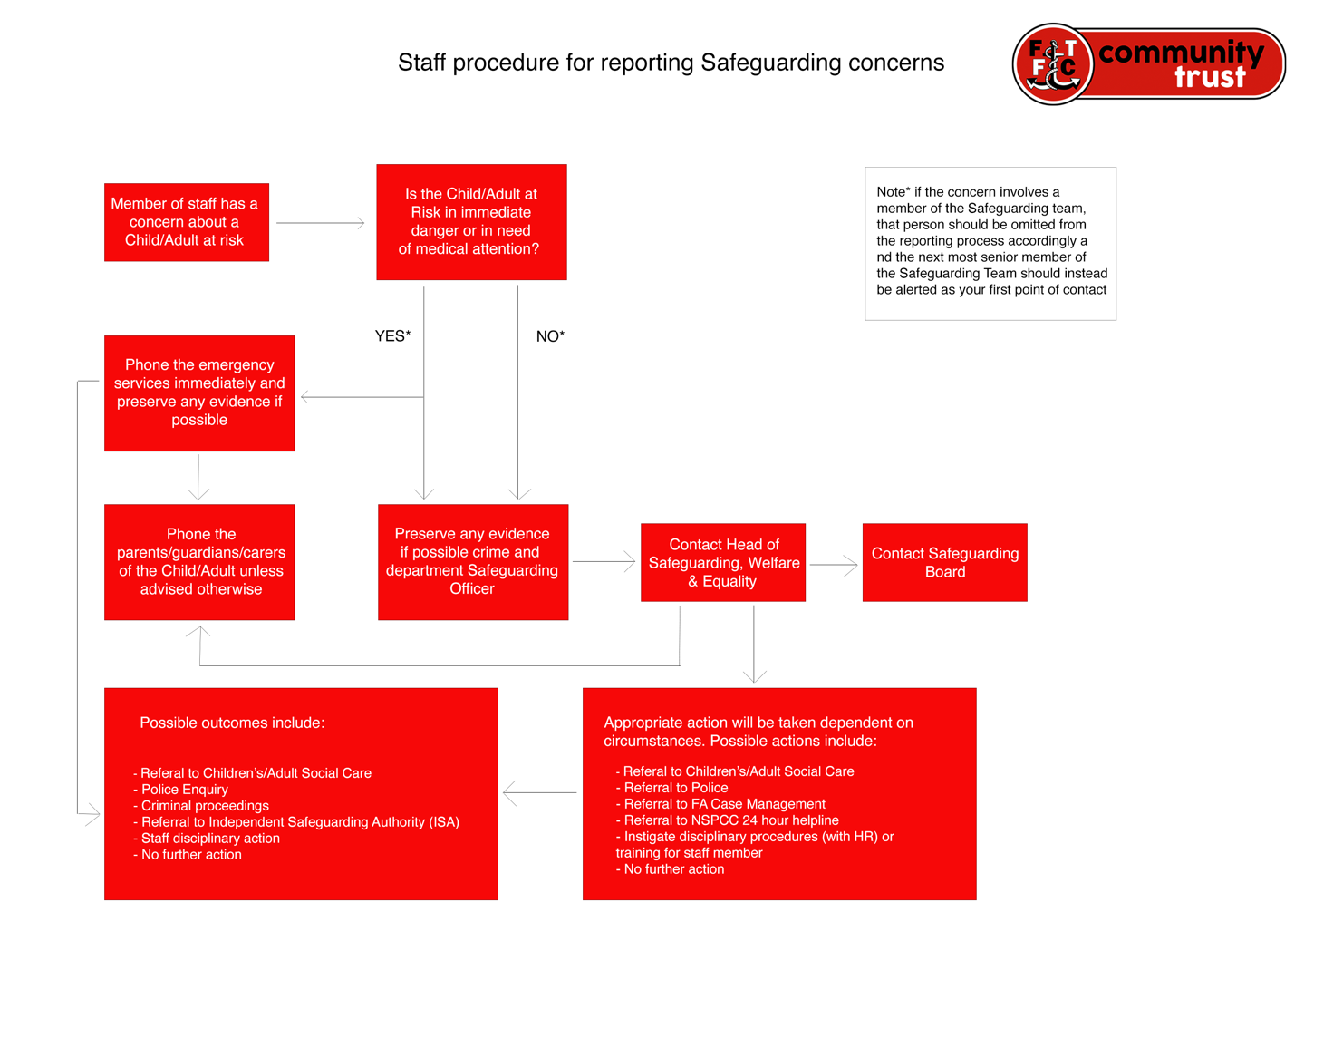

Appendix B: Recording form for safeguarding concerns

Recording Safeguarding Concerns Form

Staff, volunteers and regular visitors are required to complete this form and pass it to their departmental Safeguarding Officer if they have a safeguarding concern about a Child or Adult at Risk they have come into contact with.

Full name of child | Date of Birth | School/Team/Session | Your name and position
Nature of concern/disclosure
Please include where you were when a disclosure was made, what you saw, who else was
there, what did the child/adult say or do and what you said.

Was there an injury? Yes / No Did you see it? Yes / No

Describe the injury:

Have you filled in a body map to show where the injury is and its approximate size?

Yes / No

Was anyone else with you? Who? Their position?

Who are you passing this information to?

Name: Position:

Date: Time:
Your signature: Date:
Action taken by Safeguarding Officer:

Safeguarding Officer Signature:

Date referred to Head of Safeguarding, Welfare and Equality:

Action taken by Head of Safeguarding, Welfare and Equality:

Report/referral made to…?

Parents informed? Yes / No (If No, state reason)

Appendix C: Body Maps

Feedback given to…?

Head of Safeguarding, Welfare & Equality name:

Head of Safeguarding, Welfare & Equality Signature:

Date:

Appendix C: Safeguarding body map’s

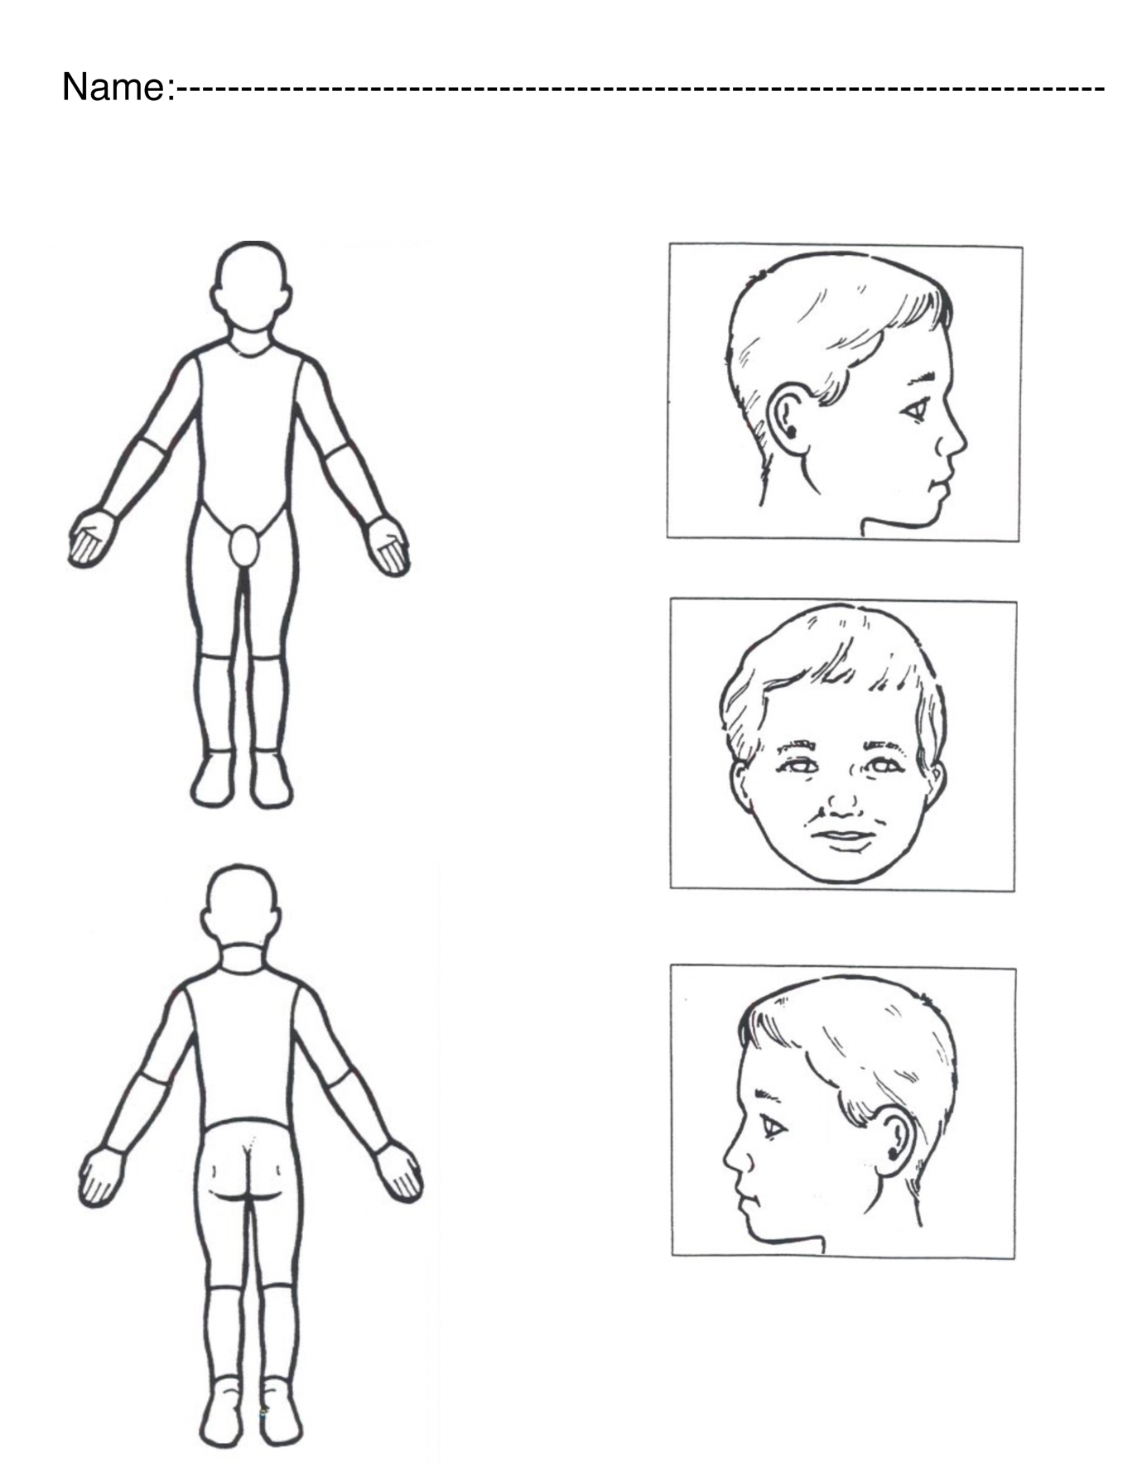

Appendix D: Action taken when a child is referred to local authority children’s social services flowchart

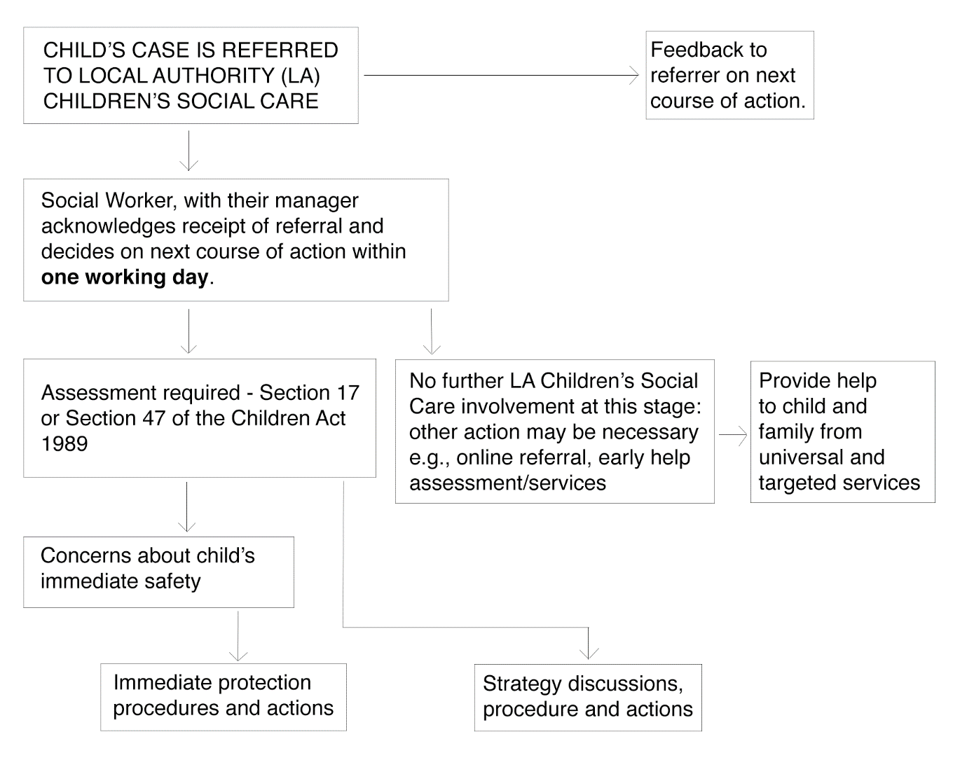

This policy has been agreed and is endorsed by the board of Trustees.

Signed on behalf of the Trustees

Name of Trustee – Safeguarding lead:

Jeremy Quartermain

Signature:

Date of policy review: 3.10.2020
V 4.0

